­

==================

sudo touch /opt/Dentread\_V2

echo "server {

listen 80;

server\_name \*;

client\_max\_body\_size 100M;

location = /favicon.ico { access\_log off; log\_not\_found off; }

location /static/ {

root /opt/dentread/Dentread\_V2;

}

location / {

include proxy\_params;

proxy\_pass http://unix:/run/gunicorn.sock;

}

}

" >> /opt/Dentread\_V2

====================

Hi Team,

Please find the documents attached in this email regarding server software installation on the following topics :

1. Curl Installation in windows  
2. SAMHS manual for a client  
3. V1 instance build update process  
4. Moodle installation process  
5. Limesurvey installation process  
6. NSC jar installation and deployment process  
7. Koha installation process  
8. Toonimo script configuration  
9. PHP 7 installation on windows  
10. Academia installation on windows server  
11. Au live data backup script configuration  
12. Msteams integration on windows and ubuntu   
13. Spring microservice deployment  
14. Login page HTML changes for google sso integration

15. ADFS integration with academia

16. Azure integration with academia

mysql -u ss\_root -p sommet\_demo < all\_city\_table\_data.sql

command to create user for 1 Day password expiration.

               Query to create a user for 1 Day password expiration.

CREATE USER 'test'@'%' identified by 's3r0s0ft';                              
ALTER USER 'test'@'%' PASSWORD EXPIRE INTERVAL 1 DAY;

select user, host, password\_lifetime from mysql.user where user like 'test';

select user from mysql.user;                                                           ====>>>> to check the user

ALTER USER `test`@`%` IDENTIFIED BY 'qwerty';                       ======>>>>> to re-assign new password for existing user

ALTER USER 'test'@'%' PASSWORD EXPIRE INTERVAL 1 DAY;  ==>>>>> again run this command for 1 day password expiry

==== break jenkins passwd ====

<https://www.serverlab.ca/tutorials/linux/administration-linux/how-to-reset-jenkins-admin-users-password/>

sudo vi /var/lib/jenkins/config.xml

<useSecurity>**true**</useSecurity> :::::: true replce --- false (<useSecurity>false</useSecurity>

)

===================

firefox auto-refresh block

about:config

accessibility.blockautorefresh

======================================

**----To check size of database in GB ------**  
SELECT TABLE\_SCHEMA AS `Database`,  ROUND(SUM(DATA\_LENGTH + INDEX\_LENGTH) / 1024 / 1024 / 1024, 2) AS `Size (GB)`  FROM information\_schema.TABLES WHERE TABLE\_SCHEMA="**db\_name**";  
  
----To check size of database in MB ------

SELECT TABLE\_SCHEMA AS `Database`,  ROUND(SUM(DATA\_LENGTH + INDEX\_LENGTH) / 1024 / 1024, 2) AS `Size (MB)`  FROM information\_schema.TABLES WHERE TABLE\_SCHEMA="db\_name";  
  
  
**----To check size of All databases in GB ------**  
SELECT table\_schema AS "Database Name",   
ROUND(SUM(data\_length + index\_length) / 1024 / 1024 / 1024, 2) AS "Size in (GB)"   
FROM information\_schema.TABLES   
GROUP BY table\_schema;

**----To check size of All databases in MB ------**  
SELECT table\_schema AS "Database Name",  
ROUND(SUM(data\_length + index\_length) / 1024 / 1024, 2) AS "Size in (MB)"  
FROM information\_schema.TABLES  
GROUP BY table\_schema;

====Azure new HDD attach in linux VM === after attached HDD- run below CMD inside linux VM

135 sudo parted /dev/sda

136 sudo parted /dev/sda --script mklabel gpt mkpart xfspart xfs 0% 100%

137 lsblk

138 mkfs.xfs /dev/sda1

139 lsblk

140 partprobe /dev/sda1

141 lsblk

142 sudo mount /dev/sda1 /root/node

xfs\_growfs /dev/sdc

=========

talenet

**\*\*\*\*\*\*\*\*\*\*\*\*\*\*\*\*\*\*\*\*\* Kernel Downgrade \*\*\*\*\*\*\*\*\*\*\*\*\*\*\*\*\*\*\*\*\*\*\*\***  
  
#To Check Current Kernel Version  
uname -r  
  
#To check installed kernel version  
find /boot/vml\*  
  
#Install kernel version - 1070  
sudo apt install linux-image-5.4.0-1070-azure   
  
find /boot/vml\*  
  
#To Remove kernel version - 1085  
sudo apt remove linux-image-5.4.0-1085-azure   
sudo apt remove linux-image-unsigned-5.4.0-  
  
#To remove kernel version - 1086  
sudo apt remove linux-image-5.4.0-1086-azure   
sudo apt remove linux-image-unsigned-5.4.0-  
  
find /boot/vml\*  
  
#To remove module kernel version 1085 & 1086  
cd /boot/  
sudo rm -rf \*-5.4.0-1085-azure  
sudo rm -rf \*-5.4.0-1086-azure

========= Azure- Backup =============

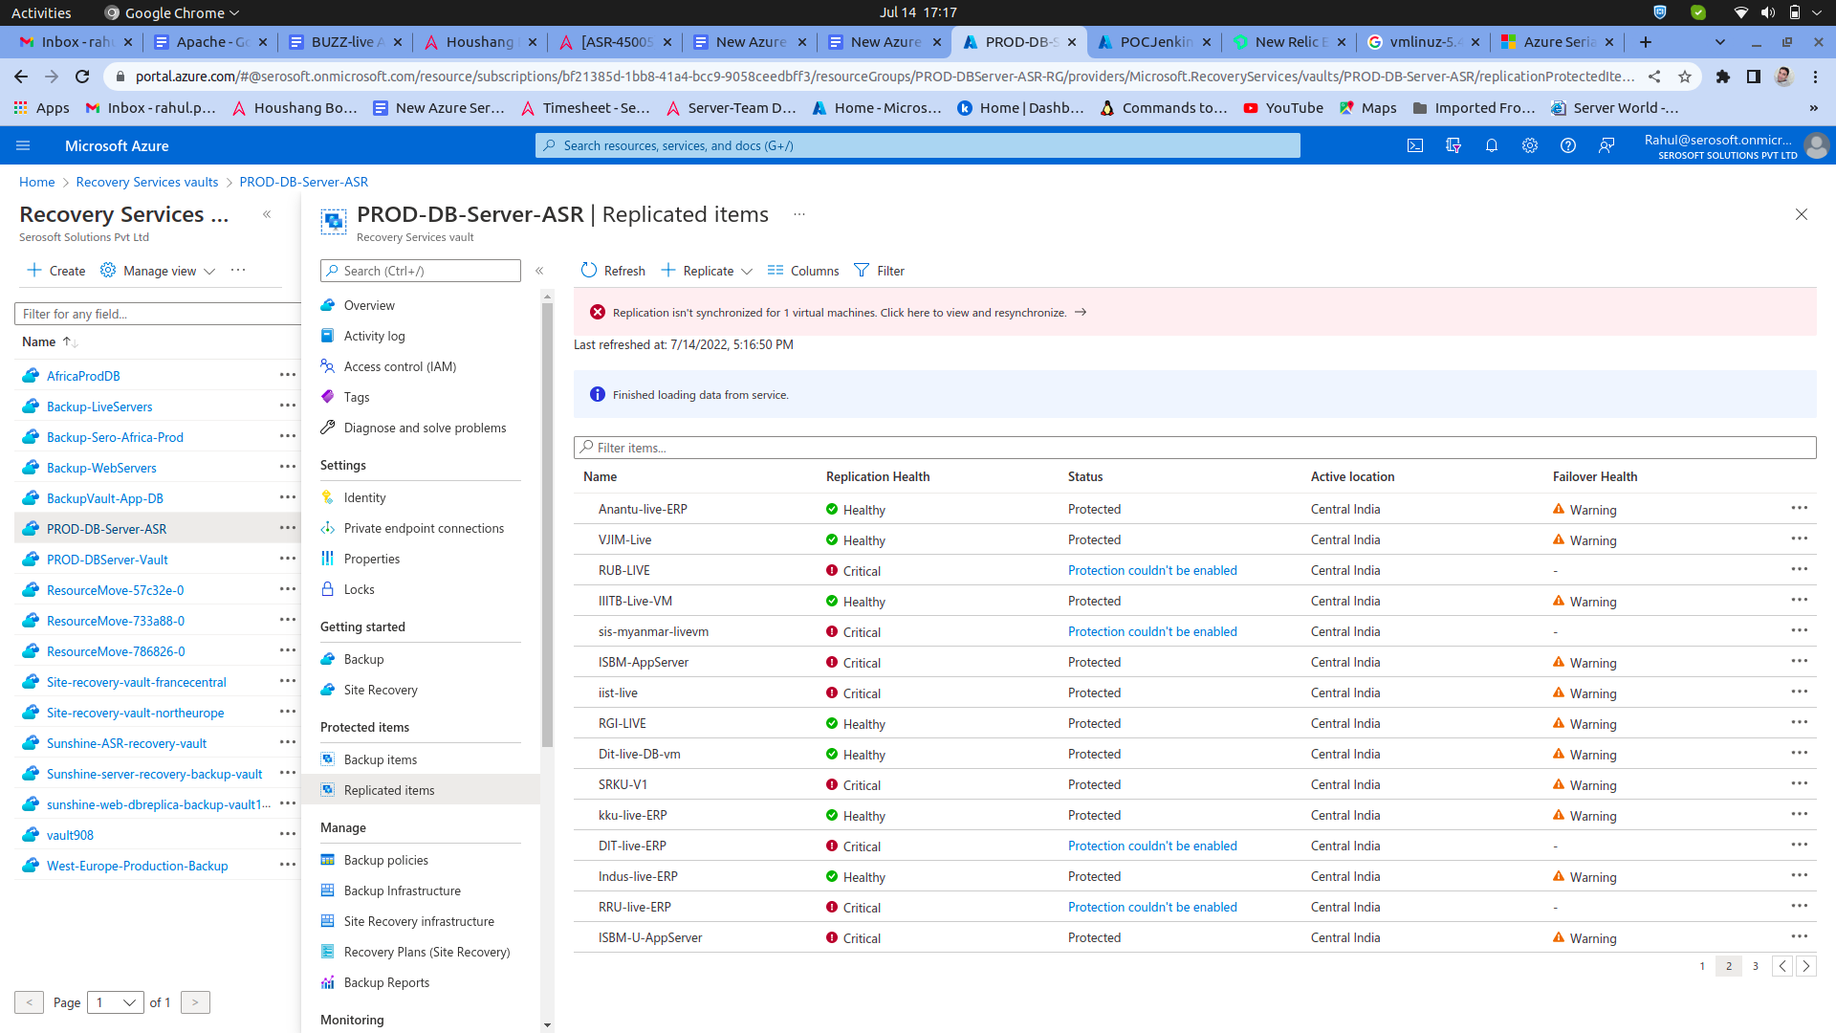

===========

**\*\*\*\*\*\*\*\*\*\*\*\*\*\*\*\*\*\*\*\*\* Kernel Downgrade \*\*\*\*\*\*\*\*\*\*\*\*\*\*\*\*\*\*\*\*\*\*\*\***  
<https://learn.microsoft.com/en-us/azure/site-recovery/azure-to-azure-support-matrix>

#To Check Current Kernel Version  
uname -r  
  
#To check installed kernel version  
find /boot/vml\*  
  
#Install kernel version - 1070  
sudo apt install linux-image-5.4.0-1070-azure   
  
find /boot/vml\*  
  
#To Remove kernel version - 1085  
sudo apt remove linux-image-5.4.0-1085-azure   
sudo apt remove linux-image-unsigned-5.4.0-  
  
#To remove kernel version - 1086  
sudo apt remove linux-image-5.4.0-1086-azure   
sudo apt remove linux-image-unsigned-5.4.0-  
  
find /boot/vml\*  
  
#To remove module kernel version 1085 & 1086  
cd /boot/  
sudo rm -rf \*-5.4.0-1085-azure  
sudo rm -rf \*-5.4.0-1086-azure

|  |
| --- |
|  |

=======

load CPU

run below cmd ====>>>>> yes > /dev/null &

[https://www.tecmint.com/linux-cpu-load-stress-test-with-stress-ng-tool/](https://www.tecmint.com/linux-cpu-load-stress-test-with-stress-ng-tool/" \t "_blank)

lsof -u www-data

lsof -u extra

==============aus-demo msg tables skip =============

-- Command to take dump skipping a table sed '/INSERT INTO `msg\_recipient\_log/d' DBdump.sql > reduced.sql

i am checking of my capability in knowledge

==========

===========**==== 22-04-2022=**===============

============14.04 to 16.04 os upgrade ==============

https://www.linode.com/docs/guides/upgrade-to-ubuntu-16-04/

apt-get update && apt-get upgrade

apt-get install update-manager-core

vim /etc/update-manager/release-upgrades (check this == >>> Open /etc/update-manager/release-upgrades and verify that the Prompt value is set to lts: >> Prompt=lts)

do-release-upgrade (it's taking time )

lsb\_release -a

cat /etc/os-release

after VM restart

==== ======== 16.04 to 18.04 ===============

cat /etc/os-release

apt-get update

apt-get upgrade

apt dist-upgrade

apt-get install update-manager-core

do-release-upgrade

cat /etc/os-release

after VM restart

=========== Kernal version downgrade and upgrade  [=============https://www.cyberciti.biz/faq/howto-upgrading-the-ubuntu-linux-kernel/](https://www.cyberciti.biz/faq/howto-upgrading-the-ubuntu-linux-kernel/" \t "_blank)

**===========Azure VM cost optimaization =============**

https://azure.microsoft.com/en-in/pricing/calculator/

https://azure.microsoft.com/en-in/pricing/calculator/?&ef\_id=Cj0KCQiAtbqdBhDvARIsAGYnXBMnIiL1ZqcpQql35REY\_IbItrDUq9t9K6uJXnNSAVZEsurnTaZoceMaAu2rEALw\_wcB:G:s&OCID=AIDcmmf1elj9v5\_SEM\_Cj0KCQiAtbqdBhDvARIsAGYnXBMnIiL1ZqcpQql35REY\_IbItrDUq9t9K6uJXnNSAVZEsurnTaZoceMaAu2rEALw\_wcB:G:s&gclid=Cj0KCQiAtbqdBhDvARIsAGYnXBMnIiL1ZqcpQql35REY\_IbItrDUq9t9K6uJXnNSAVZEsurnTaZoceMaAu2rEALw\_wcB

**==================applynow .war configruation ============**

/opt/serosoft/online\_tomcat-9/webapps/applynow/app/

vim constant.js

/opt/serosoft/online\_tomcat-9/webapps/applynow/WEB-INF/classes

vim database.properties

vim log4j.properties

vim application.properties

after start applynow tomcat

==============================================

======================= audit log ====================

https://www.theurbanpenguin.com/installing-the-linux-audit-system-on-ubuntu-18-04/

https://www.youtube.com/watch?v=AGJWzdHN6BE&t=129s

sudo apt update

sudo apt install bash-completion

sudo apt-get install auditd audispd-plugins -y

sudo service auditd status

sudo systemctl enable auditd

sudo auditctl -l

sudo auditctl -l

sudo adduser testuser

sudo auditctl -w /etc/passwd -p wa -k user-modify

sudo cat /var/log/audit/audit.log | grep user-modify

sudo auditctl -w /etc/hosts -p wa -k host-modify

sudo cat /var/log/audit/audit.log

sudo apt install -y auditd audispd-plugins

**============= azure-ad check on tomcat ==**

https://buzzuat-azure-ad.academiaerp.com/authacademiacontroller/secureazurepage

**open it on broweser**

**buzzafrica.southafricanorth.cloudapp.azure.com:9099/authacademiacontroller/secureazurepage**

=====================mysql 8===========================

How to Install MySQL 8.0 on Ubuntu 18.04

s3r0s0ft

**Kindly install the MySQL-8.0.21 version on any instance (character-set issue utf8mb3 resolved in this version)**

**Steps as follows -**

**Step 1.** go to [https://downloads.mysql.](https://downloads.mysql.com/archives/community/" \t "_blank) & download 1st package as shown in attached image.

or download tar file which is attached in this email.

**Step 2.** untar the file name using below command

**tar -xvf mysql-server\_8.0.21-**

Step 3. install the package using below command

**sudo dpkg -i \*.deb**

Step 4. Run below command to install MySQL.

**sudo apt-get install -f**

             Provide root password when asked.

Step 5 . After installation of MySQL kindly run below secure installation command.

**mysql\_secure\_installation**

Step 6. after installation of MySQL 8.0.21 kindly create ss\_root user & provide all permissions using below command.

**CREATE USER 'ss\_root'@'%' IDENTIFIED BY 's3r0s0ft';  
GRANT ALL PRIVILEGES ON \*.\* TO 'ss\_root'@'%' WITH GRANT OPTION;  
FLUSH PRIVILEGES;**

==============08-02-2022 ==============>>>>>>>>>>>>>>

https://tastethelinux.com/how-to-install-mysql-8-ubuntu-18-04-linux/

=======================

**===========>>>>> ssl certificate == pfx to .crt .csr .pem ============**

https://medium.com/beingcoders/easy-way-to-convert-pfx-to-crt-key-files-in-10-minutes-683849242c65

https://www.sslshopper.com/ssl-converter.html

#openssl pkcs12 -in samplefilename.pfx -nocerts -out samplefilenameencrypted.key

#openssl pkcs12 -in samplefilename.pfx -nocerts -out samplefilenameencrypted.key

## openssl pkcs12 -in filename.pfx -nocerts -out key.pem

=============>>>>>>>>>>>>>>>>>>>===========

https://www.cyberciti.biz/tips/how-do-i-find-out-linux-cpu-utilization.html

**=======MSG\_QRTZ\_JOB\_DETAILS === rename tables ====**

update search\_table set dbTableName=upper(dbTableName),i18nDisplayCode=upper(i18nDisplayCode)

where dbTableName like 'qrtz%';

alter table msg\_qrtz\_blob\_triggers rename MSG\_QRTZ\_BLOB\_TRIGGERS;

alter table msg\_qrtz\_locks rename MSG\_QRTZ\_LOCKS;

alter table msg\_qrtz\_calendars rename MSG\_QRTZ\_CALENDARS;

alter table msg\_qrtz\_cron\_triggers rename MSG\_QRTZ\_CRON\_TRIGGERS;

alter table msg\_qrtz\_fired\_triggers rename MSG\_QRTZ\_FIRED\_TRIGGERS;

alter table msg\_qrtz\_paused\_trigger\_grps rename MSG\_QRTZ\_PAUSED\_TRIGGER\_GRPS;

alter table msg\_qrtz\_scheduler\_state rename MSG\_QRTZ\_SCHEDULER\_STATE;

alter table msg\_qrtz\_simple\_triggers rename MSG\_QRTZ\_SIMPLE\_TRIGGERS;

alter table msg\_qrtz\_simprop\_triggers rename MSG\_QRTZ\_SIMPROP\_TRIGGERS;

alter table msg\_qrtz\_triggers rename MSG\_QRTZ\_TRIGGERS;

=========== show dead lock table =======================

SELECT \* FROM information\_schema.innodb\_trx t JOIN information\_schema.processlist p ON t.trx\_mysql\_thread\_id = p.id;

====================== live security ===========================

sudo vim /etc/security/limits.conf

\* hard nofile 500000

\* soft nofile 500000

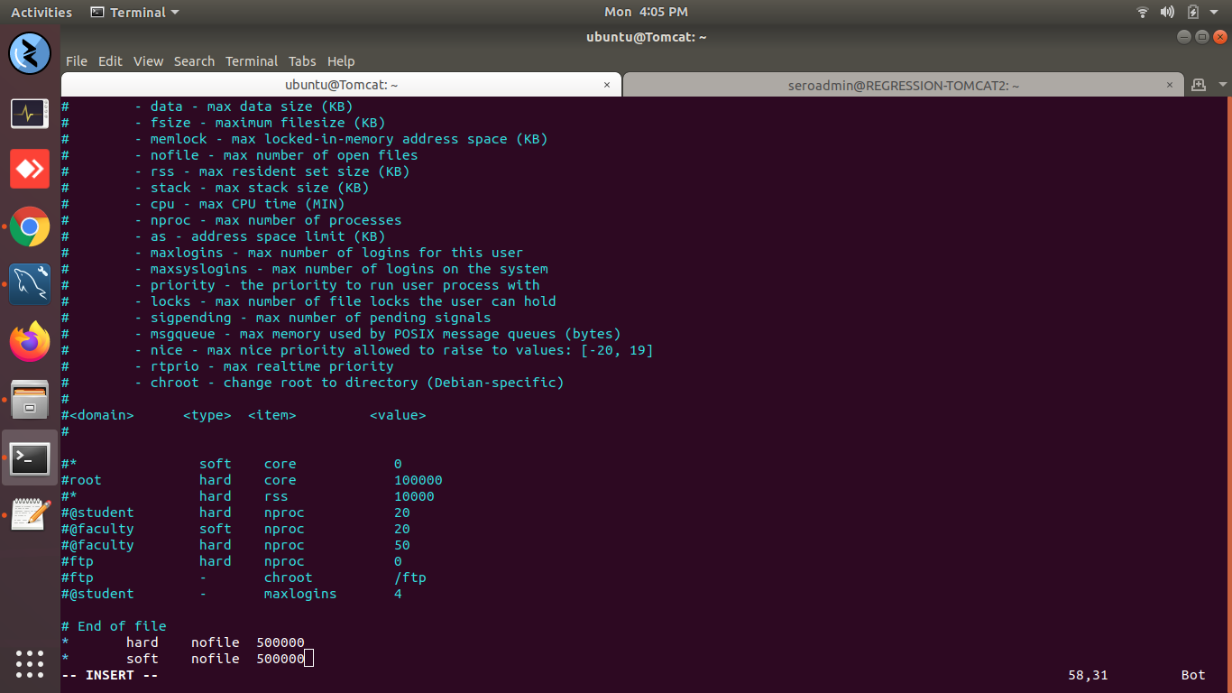

================

erorr === dpkg: error: dpkg frontend is locked by another process

lsof /var/lib/dpkg/lock-frontend

sudo rm /var/lib/dpkg/lock-frontend

sudo dpkg --configure -a

**============ only nov month ticket showing ==== jira ======**

https://serosoft.atlassian.net/issues/?filter=13931&jql=project%20%3D%20ASR%20AND%20IssueOwnerSetOn%20%3E%3D%202021-11-01%20AND%20IssueOwnerSetOn%20%3C%3D%202021-11-30%20ORDER%20BY%20created%20DESC

project = ASR AND IssueOwnerSetOn >= 2021-11-01 and IssueOwnerSetOn <= 2021-11-30 AND "IssueOwner[User Picker (single user)]" = 5fb51c80aca10c00692f67ed ORDER BY created DESC

============== **All server installation process** ==============

<https://www.server-world.info/en/>

https://www.server-world.info/en/note?os=Ubuntu\_18.04&p=zabbix40&f=1

============== **json for checking API** ==============

{ "clientId": "aim-read-write-client", "username": "parth", "password": "parth123" }

http://student-preprod-app.southafricanorth.cloudapp.azure.com:9090/resources/index.html

============ setfacl ============

setfacl -m u:somesh:7 /var/www/html/common/

setfacl -m u:rahul:5 /var/www/html/common/

setfacl -m u:abhi:4 /var/www/html/common/

7= fully permission

5= rX permission

4= r permission

1= e permission­

**remove setfalcl**

sudo setfacl -b /home/seroftp/ftp/files

--------------------------------------------

**VM Name: V1-build-server (Testing V1)**

**RGName: V1-build-server-RG**

**OS: Ubuntu Server 16.04 LTS**

**DEMO-DB-Server** **(V1)**

**Private IP: 12.0.3.20**

**Live DB Server  (V1)**

**RGName: PROD-DBServer**

**VMName: PROD-DBServer**

**AzureDNS: prod-dbserver.centralindia.cloudapp.azure.com**

**Username: seroadmin**

**Password: AXf8t9NzkFxXjdhbvF8H3bHbngRfTe3h6UsvXt23SQ**

**Public IP: 13.71.17.78**

**Private IP: 10.0.5.50**

**===== when shutdown server ======**

one date

#last -x|grep shutdown | head -1

all date

#last -x|grep shutdown

**==========db access from command =====**

create user 'rahulpati'@'%' identified by 'Rahul@123';

use aus\_applynow;

GRANT all privileges on aus\_applynow.\* TO 'rahulpati'@'%';

Show grants for ‘rahulpati’;

**====== one file to multiple location ==========**

### == Copying one file named foo.txt to multiple directories called /tmp/1/, /tmp/2/, and /tmp/3 using parallel ===

parallel cp pihu ::: /home/serosoft/Downloads/ /home/serosoft/Documents/ /home/serosoft/Music/

parallel cp pihu ::: location1 location2 location3

============== jenkins issues 26-10-2021 ==================

(/opt/serosoft/jenkins/jenkinsWorkspace/workspace/CodeCheckout1/serosoft-academia-parent/serosoft-academia-service/src/main/java/in/serosoft/academia/server/aspects/RequestValidatorFilter.java)

add below line and 31 number also remove old line

import org.apache.commons.lang3.StringUtils;

(remove this line == import com.itextpdf.styledxmlparser.jsoup.helper.StringUtil;)

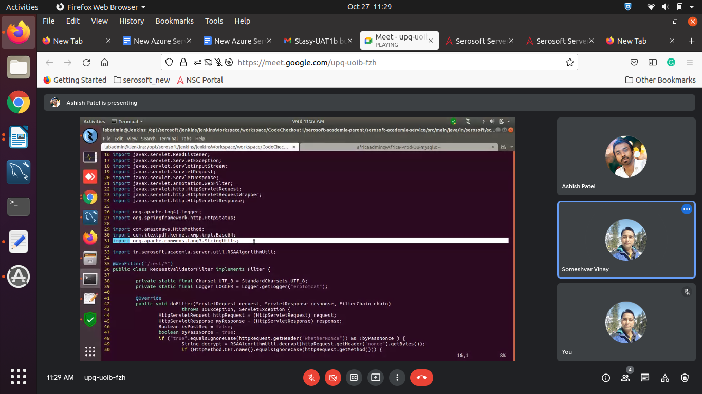

add only “s” line number 68

StringUtils;

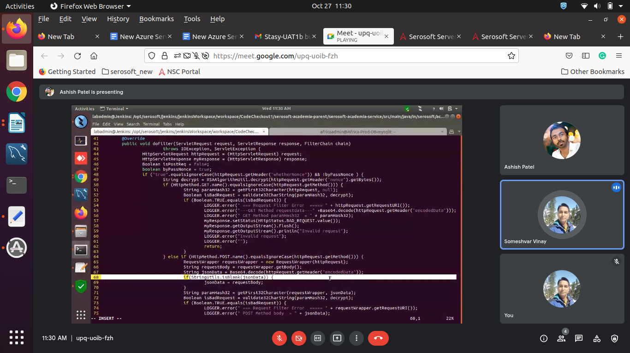

============ tomcat down / start ==============

------------------------tomcat down =========

vim tomcat\_down.sh

#!/bin/bash

pkill -9 -f tomcat\_aef\_live

-------------------- tomcat start =======

vim tomcat\_start.sh

#!/bin/bash

sh /opt/serosoft/tomcat\_aef\_live/bin/startup.sh

============ tomcat down / start ==============

===== htop =============

Show top 50 running processes ordered by highest memory/cpu usage refreshing every 1s  
  
watch -n1 "ps aux --sort=-%mem,-%cpu | head -n 50"

=========== folder files count ===================

ls | wc -l

wc dbbackup.sh

================== remote backup ==============

mysqldump --user=ss\_root --host=102.133.235.66 --password --routines --events --databases --set-gtid-purged=OFF "buzz" "buzz\_audit" > buzz\_15102021.sql

================= nfs ========================

**Server side ----**

sudo apt-get install nfs-kernel-server

vi /etc/exports (open file and past this configuration)

/opt/serosoft/v2\_uploads \*(rw,sync,root\_squash,subtree\_check)

sudo exportfs -a

service nfs-kernel-server restart

**client side ----**

sudo apt-get install nfs-common

sudo vi /etc/fstab

192.168.30.40:/opt/serosoft/v2\_uploads /opt/serosoft/v2\_uploads nfs defaults 0 0

sudo mount 192.168.30.40:/opt/serosoft/v2\_uploads /opt/serosoft/v2\_uploads

check

#df -Th

=========== mydbops =====================

[https://tickets.mydbops.com/support/tickets/new](https://www.google.com/url?q=https://tickets.mydbops.com/support/tickets/new&sa=D&source=hangouts&ust=1633068272608000&usg=AOvVaw10TyDXMPKg-L_Eu8V1YMpk)

<https://tickets.mydbops.com/support/tickets/new>

S@123vinay

============== ping block =================

(0=mean disable)

sudo sysctl --w net.ipv4.icmp\_echo\_ignore\_all=0

(1=mean enable)

sudo sysctl --w net.ipv4.icmp\_echo\_ignore\_all=1

----------------------

mangodb

[https://www.bmc.com/blogs/mongodb-mongodump/](https://www.google.com/url?q=https://www.bmc.com/blogs/mongodb-mongodump/&sa=D&source=hangouts&ust=1632566719574000&usg=AOvVaw3lIcOTuqpUG3dHme-qp6kB)

for mongodb

============== NPFIntegration ==============

host- proddb.centralindia.cloudapp.azure.com

DB name - krmu\_NPFIntegration  
user- krmu\_npfuser  
pass- Krmu@2021

port- 3306

**================= password less authentication ======**

generation ssh key gen

extra# ssh-keygen

#cd /home/extra/.ssh/

#ssh-copy-id -i /home/extra/.ssh/id\_rsa.pub seroadmin@192.168.1.4

#ssh [seroadmin@192.168.1.4](mailto:seroadmin@192.168.1.4)

(touch authorized\_keys)

**================= root logging enabled ======**

**/etc/ssh# vim sshd\_config**

**PermitRootLogin yes**

**service restart sshd**

**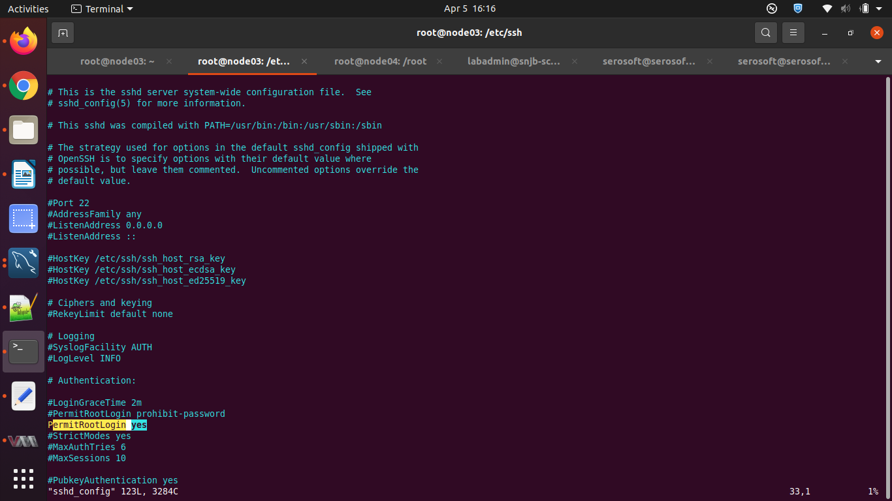**

/etc/ssh# vim sshd\_config

#ssh-keygen

ssh-copy-id -i /root/.ssh/id\_rsa.pub root@192.168.122.97

ssh root@192.168.122.97

================== ssh port change ===========

https://www.ubuntu18.com/ubuntu-change-ssh-port/

#cd /etc/ssh

# vi sshd\_config

change the 22 to 2222 port

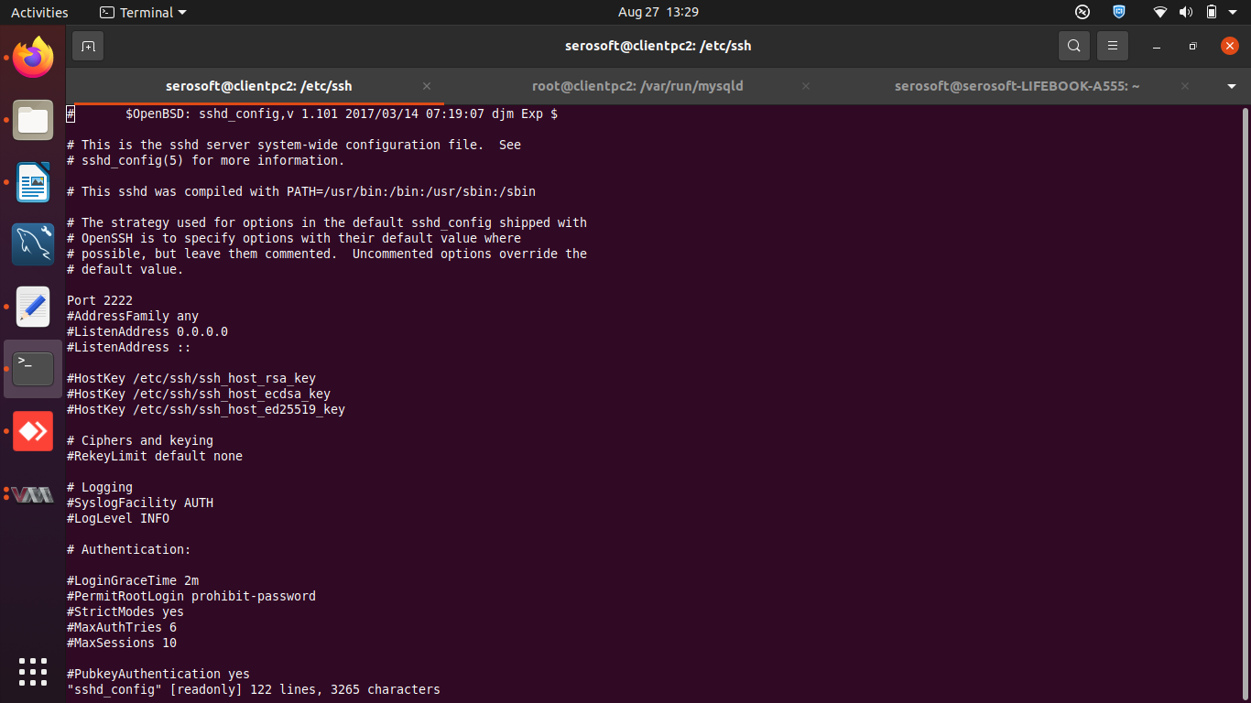

https://linuxize.com/post/how-to-setup-passwordless-ssh-login/

#cd /root/.ssh

touch authorized\_keys (past master node id\_rsa.pub)

service sshd restart

service ssh restart

user – sudo power – give to user

#vim /*etc*/sudoers (entry user name down root user)

#service sshd restart

#sudo ufw allow 20/tcp

#netstat -tulpn | grep ssh

----------------------------------------------------------------------

check port open cmd

netstat -tulpn | grep LISTEN

sudo ss -tulwn | grep LISTEN

$ netstat -anp tcp | grep LISTEN  
$ netstat -anp udp | grep LISTEN

================== mysql port change ===========

cd /etc/mysql/mysql.conf.d

#vi mysqld.cnf

#service mysql restart

#mysql -u root -p

mysql>show variables like 'port';

#netstat -tulpn | grep LISTEN

====== mysql password recovery ====

[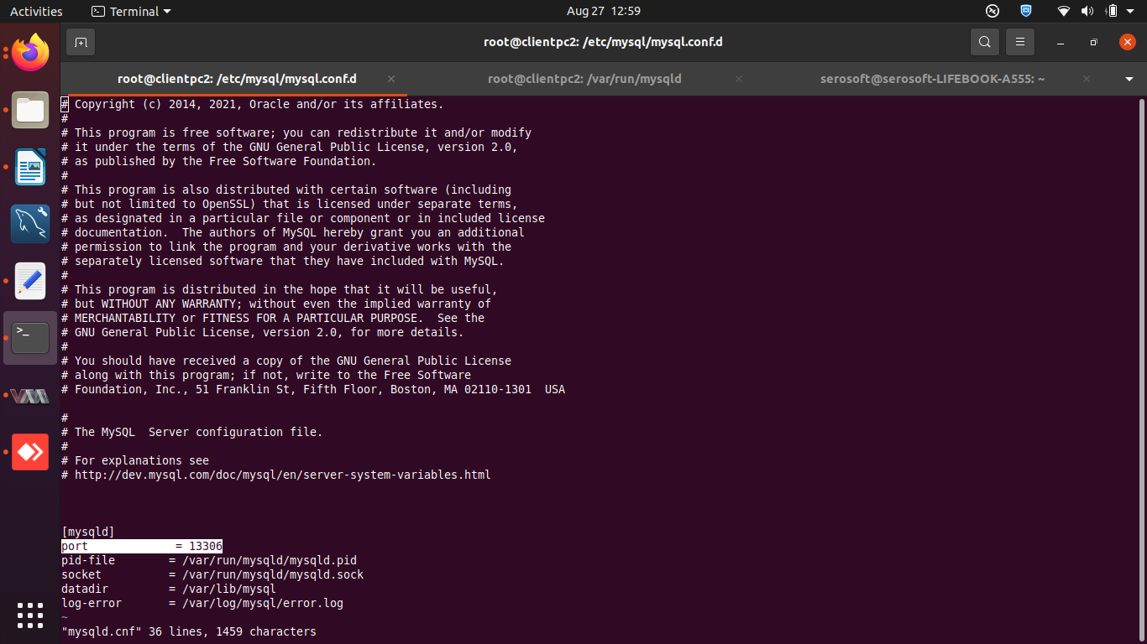https://techexpert.tips/mysql/mysql-password-recovery/](https://techexpert.tips/mysql/mysql-password-recovery/)

==============for capture === sunshine =su-demo=====

SITEKEY:

SECRETKEY

data-sitekey

===============================

port == 80, 443, 3306, 15672, public IP == **218.248.31.251**

=============tsm-live dump =============

>mysql -u ss\_root -P13306 -p

mysqldump --user=ss\_root --host=localhost --password -P13306 --routines --events --databases --set-gtid-purged=OFF "tsm" "tsm\_audit” > tsm\_audit5aguest.sql

import DB

**c> programfiles>mysql>mysql5.6>bin>**  **mysql -u ss\_root -P13306 -p <  tsm.sql**

=================== workbench 8 ==========

<https://snapcraft.io/mysql-workbench-community>

Erorr ===

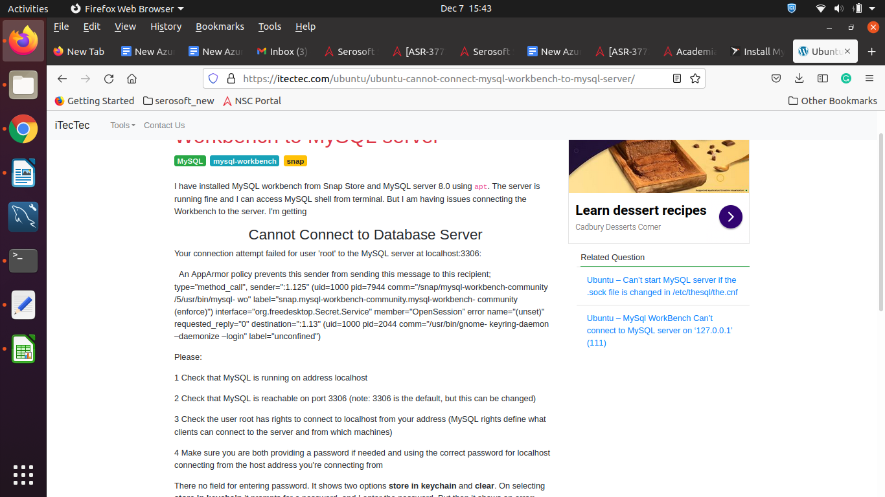

<https://itectec.com/ubuntu/ubuntu-cannot-connect-mysql-workbench-to-mysql-server/>

run this commond =========

sudo snap connect mysql-workbench-community:password-manager-service :password-manager-service

------------------------------------------

git fetch --tags -f

**====== every user history == ====**

#cat /home/vinay/.bash\_history

*#cat /home/username/.bash\_history*

**==================apache2 setting new setup =====**

/etc/apache2/sites-available : vi dit-demo.academiaerp.com.conf

change content

sudo sed -i 's/'vgutemp'/'dit\_demo'/g' dit-demo.academiaerp.com.conf

=======>>>>>> location == ‘/etc/apache2/” == workers.properties===

worker.list= **workerditdemo**

# Set properties for worker (ajp13)

worker.**workerditdemo**.type=ajp13

worker.**workerditdemo**.host=12.0.3.62

worker.**workerditdemo**.port=8009

after -----

#sudo a2ensite dit-demo.academiaerp.com.conf

#sudo service apache2 reload

==data directory

#cd ‘/var/www/html

---------------------------------------------------------------------------

==== sudemo == falsebay == Azure url add karna ==sunshine =

[https://sudemo-azure-ad.academiaerp.com/authacademiacontroller/secureazurepage](https://www.google.com/url?q=https://sudemo-azure-ad.academiaerp.com/authacademiacontroller/secureazurepage&sa=D&source=hangouts&ust=1627272821221000&usg=AFQjCNHYV4xIKpW2ib0Hb5-yCxqA4y00aw)

cd /var/www/html/sudemo/resources/js/

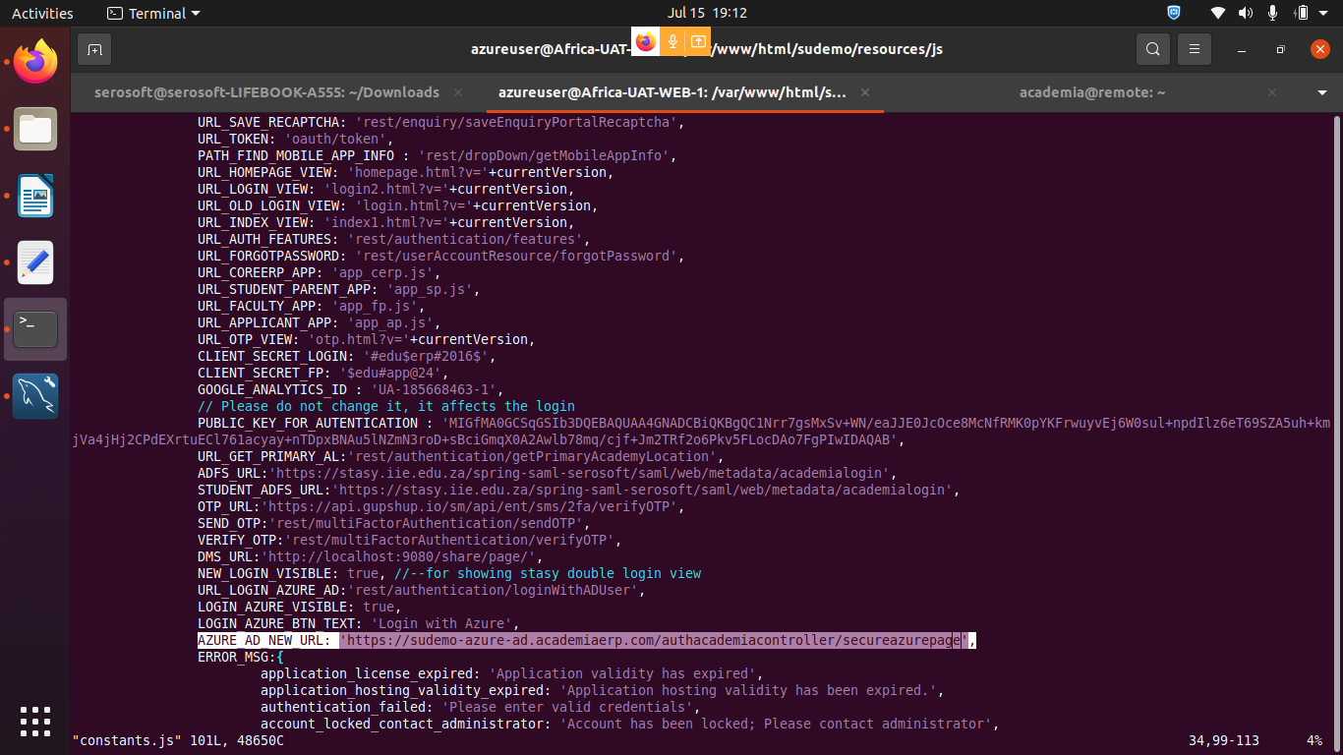

20210601104041

==================schema no exit query in jenkins ===================

INSERT INTO `schema\_version`  
(`version\_rank`, `installed\_rank`, `version`, `description`, `type`, `script`, `checksum`, `installed\_by`, `installed\_on`, `execution\_time`, `success`) VALUES ('6561', '6615', '20210601104041', 'Create VGU Views', 'SQL', 'V20210601104041\_\_Create\_VGU\_Views.sql', '1110553747', 'root', '2021-06-01 17:41:32', '18387', '1');

=====================================================

Build step 'Execute shell' marked build as failure

Email was triggered for: Failure - Any

Sending email for trigger: Failure - Any

An attempt to send an e-mail to empty list of recipients, ignored.

Finished: FAILURE

================================================

------------------------------------- Azure login disable ======

/var/www/html/ku\_demo/resources/js

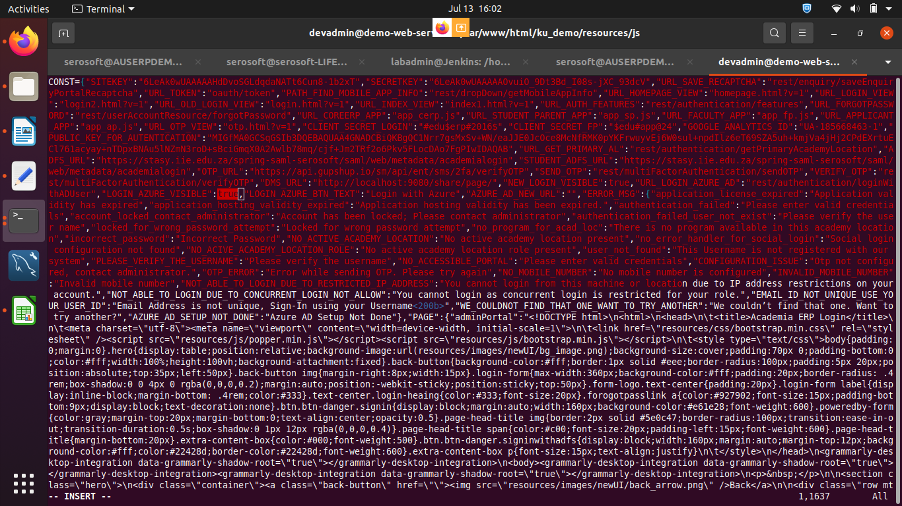

remove === true === add only :: “”

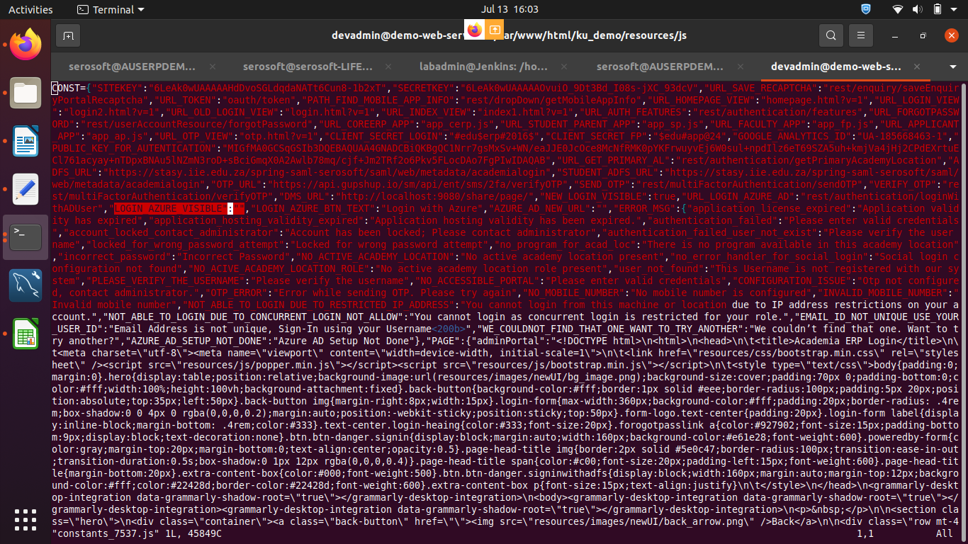

======================================================

=== windows my sql = ini = file in window OS ==

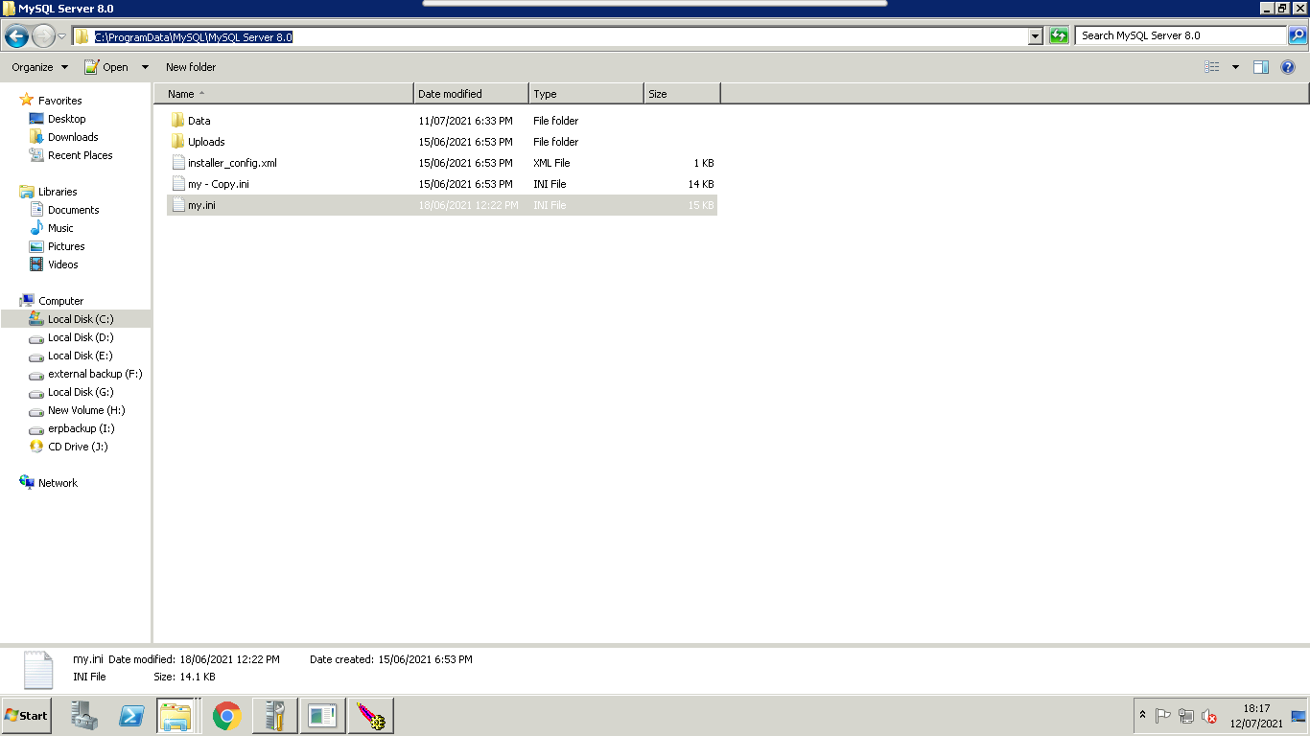

======= newrelic-infra.service --========

systemctl restart newrelic-infra.service

**====== cacerts === location ================**

sudo keytool -importcert -file /home/seroadmin/sudemo.cer -alias demo -keystore "/usr/lib/jvm/java-1.8.0-openjdk-amd64/jre/lib/security/cacerts"

error it

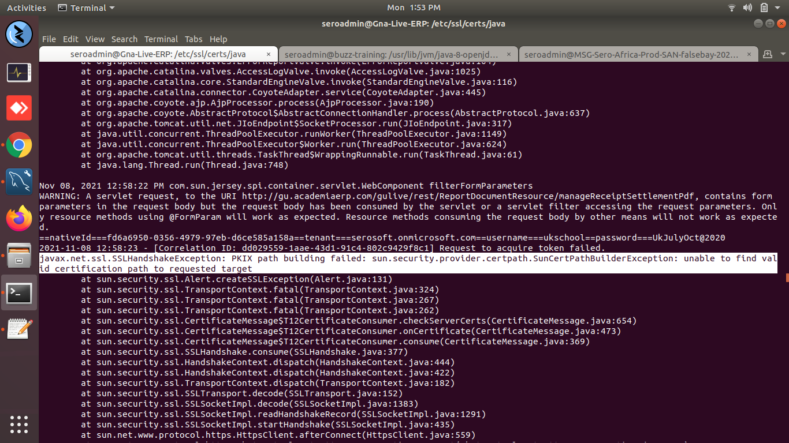

solution ==

# sudo ln -s /etc/ssl/certs/java/cacerts /usr/lib/jvm/java-8-openjdk-amd64/jre/lib/security/

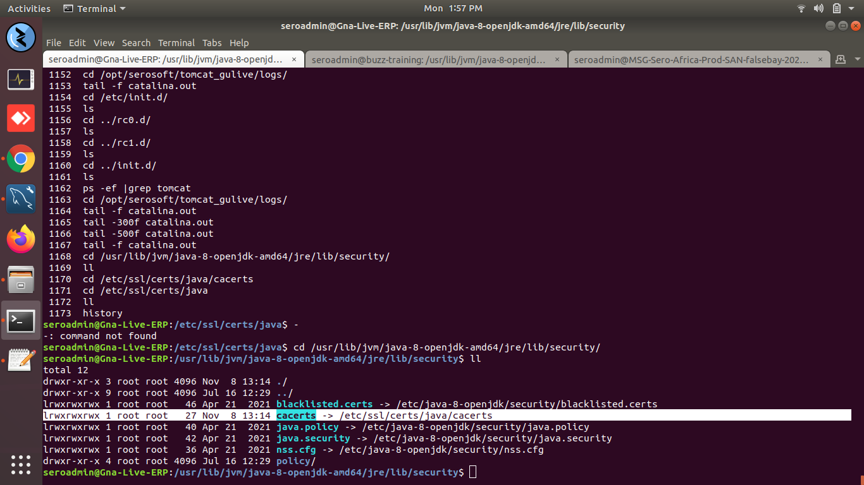

-========================================================

**serosoft-academia-service.jar == database propeties me change karna**

1- hostname and db passwd & port number >>>> database.properties

msg.war == database.properties

/opt/serosoft/tomcat7/webapps/msg\_aeischool\_demo/WEB-INF/classes/config

2- db name change >>>> database.properties / hibernet-setting.properties

msg.war === database.properties

**3- v2\_upload ka path change >>>>**

a == documnet-constant.properties

b ==batch-quartz.properties

c == log4j.properties

D == **msg.war** >>>> documnet-constant.properties / log4j.properties

/opt/serosoft/tomcat7/webapps/msg\_aeischool\_demo/WEB-INF/classes/config#

E **== === log4j.properties ==**

/opt/serosoft/tomcat-rgi-live/webapps/msg\_rgi/WEB-INF/classes/config

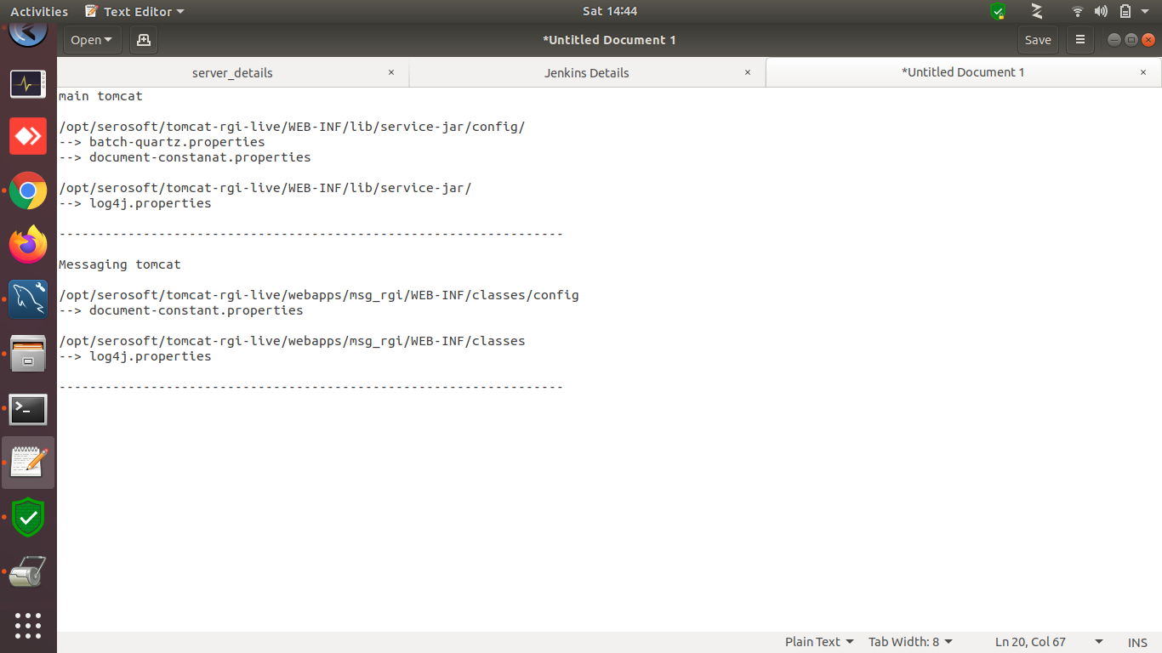

==================================================

============= ftp login issue by google crome

run this command in crome

chrome://flags/

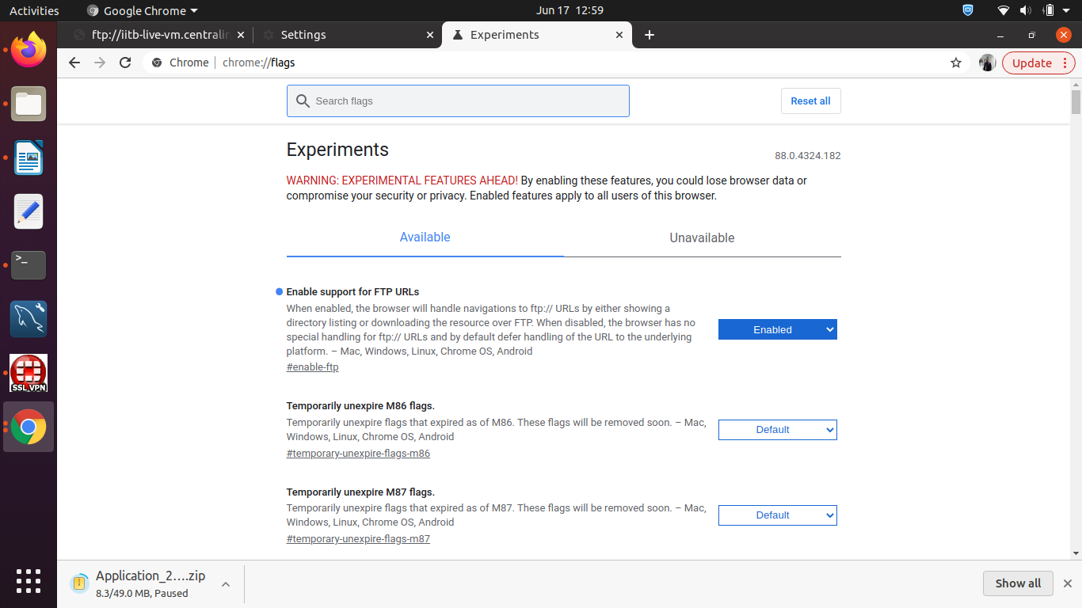

===== 24 x 7 site ====

<https://www.site24x7.com/app/client?a=f#/home/monitors>

username- [shiv.gurjar@serosoft.in](mailto:shiv.gurjar@serosoft.in)

pass- Sero#Soft#2020

URL - [https://www.site24x7.com/app/client#/home/monitors](https://www.google.com/url?q=https://www.site24x7.com/app/client%23/home/monitors&sa=D&source=hangouts&ust=1623232481532000&usg=AFQjCNE0vv3Du20FvsL1UaI6p-W8b7LN3Q)

---------------- cpanel – pointing --------------------------------

[https://my.aspirationhosting.com/clientarea.php?action=productdetails&id=9922](https://www.google.com/url?q=https://my.aspirationhosting.com/clientarea.php?action%3Dproductdetails%26id%3D9922&sa=D&source=hangouts&ust=1622707371587000&usg=AFQjCNEXx4vf9_9r_wvucsEQQvYSHWFHzQ)

Please map the url with ip address.

sanjivanilive.academiaerp.com 103.112.11.69

================ velocity – applynow – configuration =============

1-download war in local PC >>> Extranct war >>> compased to zip

server side ::: kill applynow-tomcat

2- take backup in oldware

3- move to local PC to Remote Server zip file

replace the content old to new folder

4- cd /opt/serosoft/tomcat9\_online/webapps/applynow/app#

#sudo vi constant.js

5- cd /opt/serosoft/tomcat9\_online/webapps/applynow/WEB-INF/classes#

`sudo vi log4j.properties

1274 vi log4j.properties

1275 sudo vi database.properties

1276 sudo vi application.properties

6- start the tomcat

[https://testing-velocity.academiaerp.com/applynow/brandcampus.html](https://www.google.com/url?q=https://testing-velocity.academiaerp.com/applynow/brandcampus.html&sa=D&source=hangouts&ust=1620453827980000&usg=AFQjCNESBnMTeH-fP-_IKOOE8DfZY_Wt8w)

============== tomcat installation new ============

wget [https://archive.apache.org/dist/tomcat/tomcat-7/v7.0.93/bin/apache-tomcat-7.0.93.zip](https://www.google.com/url?q=https://archive.apache.org/dist/tomcat/tomcat-7/v7.0.93/bin/apache-tomcat-7.0.93.zip&sa=D&source=hangouts&ust=1620392656580000&usg=AFQjCNFMuULKFZmBrzgeOgNXjUjHSlTQ9A)

vi setup installaiont process

jdk 7

mysql 5.6 ya 5.7

apache2

tomcat7

------------------------------------------------------------------------------------------------

hi dosto

please save this link

thsi is for linux mail configuration

very easy to setup

https://chribonn.medium.com/howto-send-an-email-using-gmail-from-a-system-configuration-using-msmtp-and-heirloom-mailx-ubuntu-1cb2bace0c33

**============== passwd set (passwd)=============**

update users set password = '6132b021d89ccca3b52fc3d9cc217958cbbb9d73b90d01bce87b87314571913b',salt='3@sf6' where id = 1;

**============== passwd decode =============**

select \* from users;

or

mysql> select \* from users where id = 1;

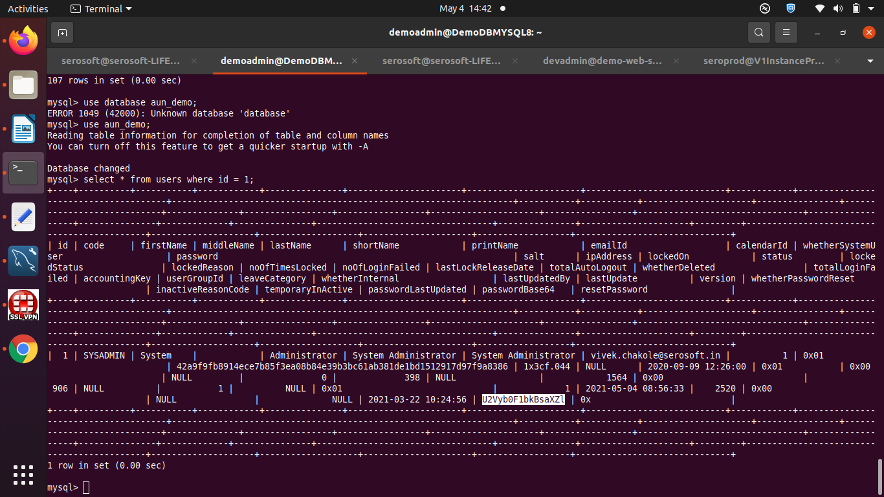

Decode it >>> https://www.base64decode.org/

===========Mango DB ---- install --------------

https://www.howtoforge.com/tutorial/install-mongodb-on-ubuntu-14.04/

=============================================

https://crontab.guru/#\*/1\_\*\_\*\_\*\_\*

crontab -e --- catalina.out null sent == every 15days ==

0 5 \*/15 \* \* cat /dev/null > /opt/serosoft/tomcat\_erp/logs/catalina.out

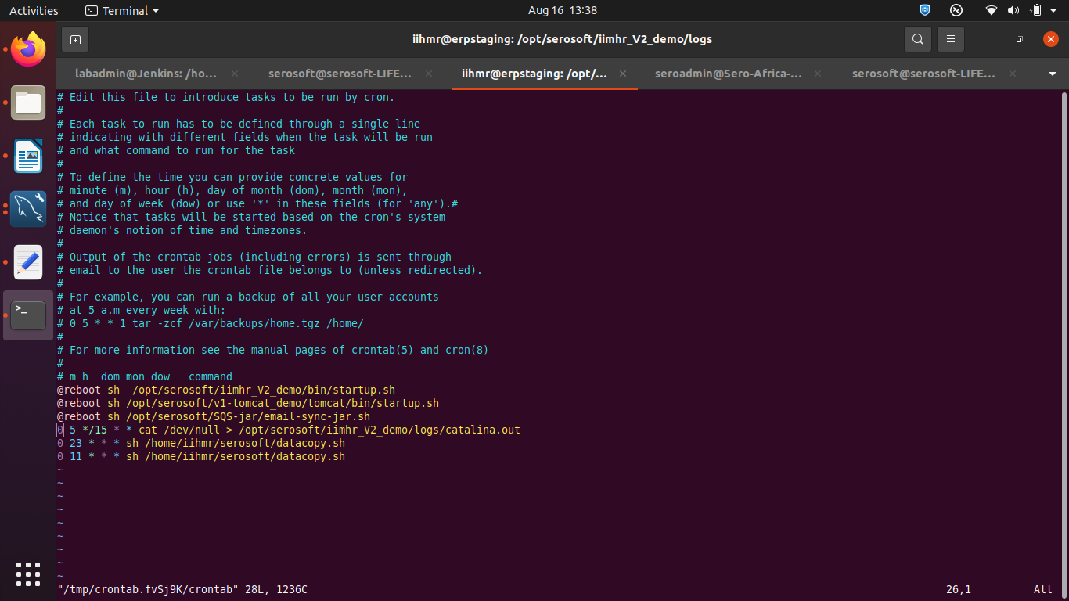

----------------------------------

===================>>>>>>>>>>>>>>>>>>>>>>>>>>>>>

crontab -e (this commant not running== #export EDITOR=/usr/bin/vim.basic)

5 4 \* \* \* /opt/tomcat\_autorestart/tomcat\_down.sh

10 4 \* \* \* /opt/tomcat\_autorestart/tomcat\_start.sh

+++++++++++++++ tomcat\_down.sh++++++++++++++++

#!/bin/bash

pkill -9 -f apache-tomcat-7.0.26

#sh /home/academia/serosoft/installation/apache-tomcat-7.0.26/bin/shutdown.sh -force

+++++++++++++++ tomcat\_start.sh ++++++++++++++++

#!/bin/bash

sh /home/academia/serosoft/installation/apache-tomcat-7.0.26/bin/startup.sh

# m h dom mon dow command

@reboot sh /opt/serosoft/apache-tomcat-7.0.94/bin/startup.sh

@reboot /bin/sleep 300 ; sh /opt/serosoft/AcademiaIntegrationModule/start.sh

@reboot /bin/sleep 320 ; sh /opt/serosoft/samlazuread\_jar/start.sh

@reboot /bin/sleep 420 ; sh /opt/serosoft/testing\_uwc\_soap-jar/start.sh

45 5 \* \* \* sudo /sbin/shutdown -r now

@reboot /bin/sleep 340 ; sh /opt/serosoft/MIMIntegration/start.sh

++++++++++++++++++++++++++++++++++++++++++++++++++++

===================>>>>>>>>>>>>>>>>>>>>>>>>>>>>>

<https://www.geeksforgeeks.org/crontab-in-linux-with-examples/>

**(17 run this every 2 minit 17 hr) = 5 baje har 2 minit me run hogi only 5 baje**

\*/2 17 \* \* \* sh /home/extra/test/backup.sh

**=== crontab logs ===**

grep CRON /var/log/syslog

**++++++++++++++ os reboot ==== run only root user =======**

last reboot

entry in crontab -e

0 5 \* \* \* sh /*sbin/reboot*

*0 5 \* \* \* systemctl restart apache2 (only root user )*

5 13 \* \* \* sudo /sbin/shutdown -r now (use only restart -tested)

\*/20 \* \* \* \* cd /opt/serosoft/MIMIntegration && ./start.sh

================crontab logs

grep -in cron "Oct 21 10:" /var/log/syslog

grep -in tomcat\_mbc "Oct 21 10:" /var/log/syslog

(23 sept all data jo bana h wo data folder me cp kar do)

***==== crontab ====***

[***https://crontab.guru/#45\_5\_28\_04\_03***](https://crontab.guru/#45_5_28_04_03)

***https://www.freeconvert.com/time/ist-to-sast***

[*http://www.cronmaker.com/;jsessionid=node01qky7tvy48cv91q1jccxbcggmn1963024.node0?0*](http://www.cronmaker.com/;jsessionid=node01qky7tvy48cv91q1jccxbcggmn1963024.node0?0)

***#export EDITOR=/usr/bin/vim.basic***

(some time not open “crontab -e” file and run this command “export EDITOR=/usr/bin/vim.basic”)

***#crontab -e (entry)***

***--------------------***

*# m h dom mon dow command*

*@reboot /bin/sleep 300 ; sh /opt/serosoft/tomcat9\_buzz/bin/startup.sh*

*#@reboot sh /opt/serosoft/tomcat\_currency/bin/startup.sh*

*@reboot /bin/sleep 500 ; sh /opt/serosoft/AcademiaIntegrationModule/start.sh*

***@reboot /bin/sleep 300 ; sh/opt/serosoft/tomcat\_aun/bin/startup.sh***

*\*/2 \* \* \* \* sh /opt/serosoft/tomcat\_aun/logs/catalina-cleanup.sh*

*-------- database import script by crontab --*

*crontab entry section*

*#15 5 12 05 03 sh /home/seroadmin/dbbackup.sh*

*script*

*mysql -u ss\_root -ps3r0s0ft < aus\_demo\_2021\_06\_04\_16\_08\_15\_DB.sql*

***=============end================***

==========hostname =======

#hostnamectl

#hostnamectl set-hostname newNameHere

============== tar == gzip =========== file create ==========

Here /home/sampleArchive is the directory which needs to be compressed creating sampleArchive.tar.

The command uses –cvf options which stand for:

* c – This creates a new .tar file
* v – shows a verbose description of the compression progress
* f – file name

### Creating a .tar.gz File in Linux

**#tar -cvf sampleArchive.tar /home/sampleArchive**

tar -cvzf iihmr\_audit23apl.sql.taz iihmr\_audit23apl.sql

tar -cvpzf /home/iihm/$NOWDATE/$NOWTIME-v2\_upload\_mainbackup.tar.gz /home/iihmr/serosoft/v2\_uploads

### How to Unzip .tar Files in Linux

#tar -xvf sampleArchive.tar

### How to Extract Multiple Files from .tar Archives

In case you want to extract multiple files, use the below format of the command:

#tar -xvf sampleArchive.tar "file1" "file2"

https://www.hostinger.in/tutorials/linux-tar-command-with-examples/#:~:text=Tar%2C%20when%20it%20comes%20to,features%20of%20files%20and%20directories.

-----------------------

tar -cf dbbackups-$NOWTIME.tar \*$NOWTIME.sql

gzip dbbackups-$NOWTIME.tar

extra for this file --

tar -xvf 02-09-2021-16-19-images.tar.gz

=======================================================

**===== ssl skip ====== add this line in service jar=====**

?autoReconnect\=true&amp&useSSL\=false&amp&useUnicode\=true&amp;characterEncoding\=utf-8

==== tomcat pakeges all version =====

<https://archive.apache.org/dist/tomcat>

wget https://archive.apache.org/dist/tomcat/tomcat-7/v7.0.94/bin/apache-tomcat-7.0.94.zip

===========java installation ubuntu =====

sudo add-apt-repository ppa:openjdk-r/ppa  
sudo apt-get update  
sudo apt-get install openjdk-8-jdk  
sudo update-alternatives --config java

=============**rabitmq installation in ubuntu**==========

systemctl disable rabbitmq-server.service

sudo apt-get install rabbitmq-server  
sudo rabbitmq-plugins enable rabbitmq\_management  
  
sudo rabbitmqctl add\_user gna\_demo s3r0s0ft  
sudo rabbitmqctl set\_user\_tags gna\_demo administrator  
sudo rabbitmqctl set\_permissions -p / gna\_demo ".\*" ".\*" ".\*"

rabbitmqctl list\_users (show user)

**sudo apt-get remove --auto-remove rabbitmq-server**

**sudo apt-get purge --auto-remove rabbitmq-server**

**Azure == moblie App == passwd ==== srqtmzwtxrlwmnnp**

==================================

please provide approval ASAP, Other wise we will close ticket EOD today

================ nfs -server ==============================

sudo apt-get install nfs-kernel-server

sudo vim /etc/exports

/var/www/html/ \*(rw,sync,no\_root\_squash,subtree\_check)

sudo service nfs-kernel-server restart

sudo exportfs -a

sudo exportfs -v

sudo cat /proc/fs/nfsd/versions

-----------------------------------------------------

nfs-client

sudo apt-get install nfs-common

cd *var/www/html*

*mkdir aei*

sudo vim /etc/fstab

10.0.2.5:/var/www/html/ /var/www/html/aei nfs defaults 0 0

192.168.122.117:/var/www/html /var/www/html nfs auto,noatime,nolock,bg,nfsvers=3,intr,tcp,actimeo=1800 0 0

mount 192.168.122.117:/var/www/html/aei /var/www/html/aei

mount 10.0.2.5:/var/www/html/rru /var/www/html/rru

#rru

10.0.2.5:/var/www/html/rru /var/www/html/rru nfs defaults 0 0

sudo mount -avvv

df -Th

-----------------nfs-troobulshooting ----------

for server :--

sudo service nfs-kernel-server restart

for client :-

sudo mount 11.0.4.18:/var/www/html/rgi\_od /var/www/html/rgi\_od

**===== adfs remove ===**

<button class="btn btn-danger signin" id="signInBtn" name="signin" type="button">Sign in</button><button class="btn btn-danger signinwithadfs loginwithADFS" id="signInBtnADFS" name="signin" style="display:none;" type="button"></button>

change to only (Display to none) after check

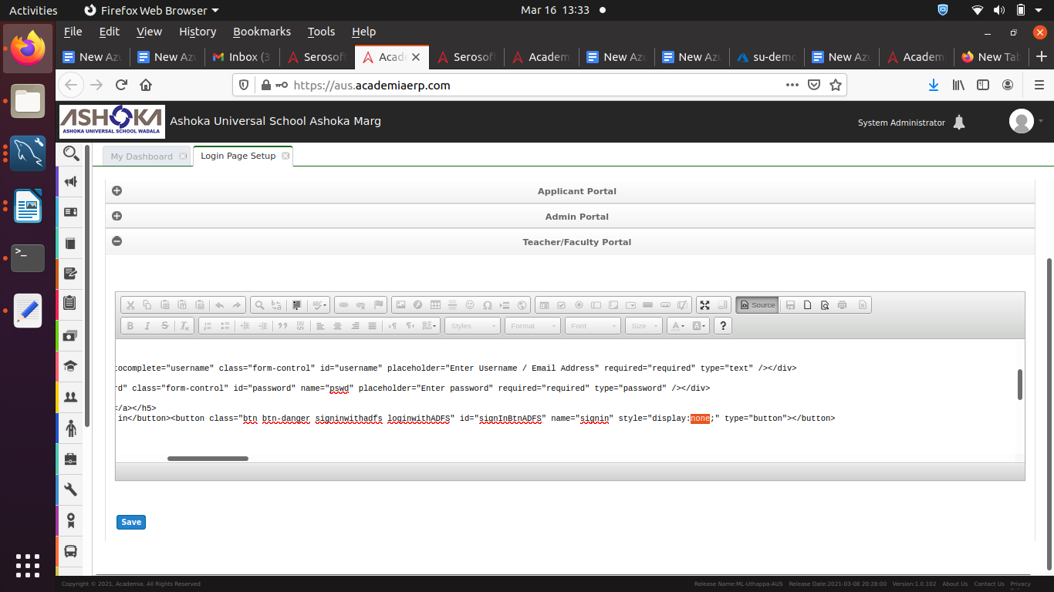

**== content change open file ===**

:%s/somesh/module/gi

old-somesh ,, new-fiel == module

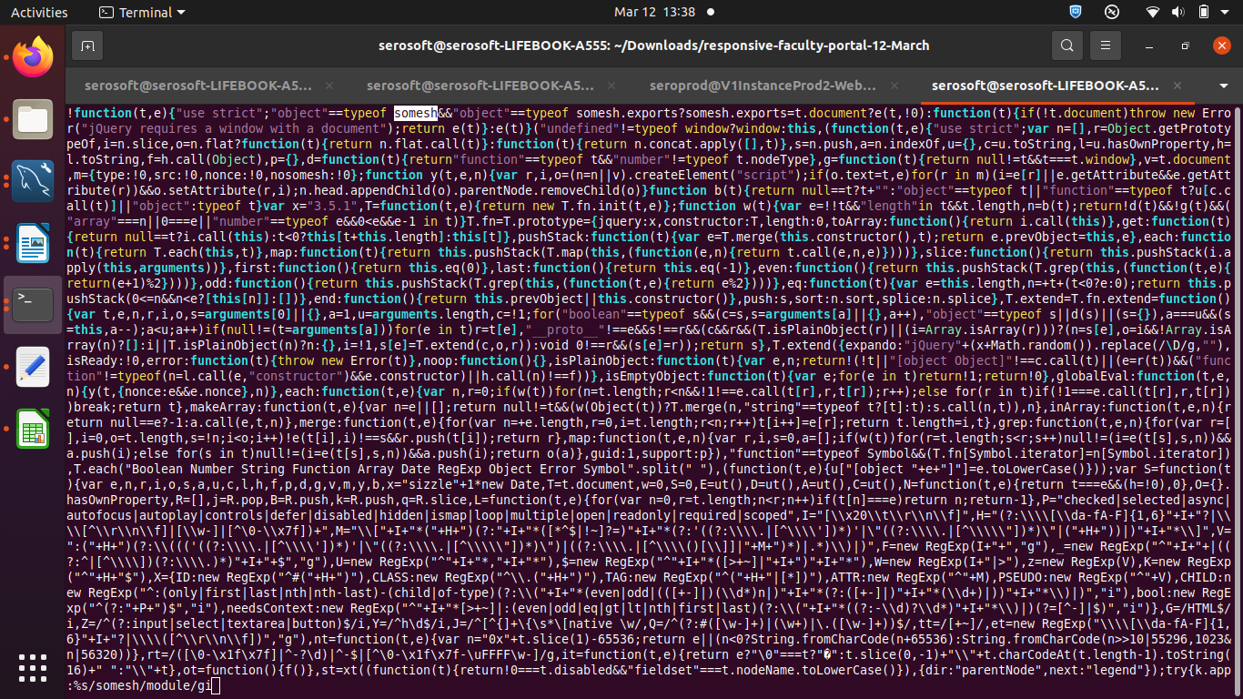

-------------------------------------------------------------------------------------

## Mysql Too many connection issue resolution technique

Resolution technique.

1) open mysqld.cnf file

    sudo vim /etc/mysql/mysql.conf.d/

2) Insert the following lines under the area named MYSQLD.

    max\_connections=4100

    max\_user\_connections=400  
    mysqlx\_max\_connections=400

3) save and exit it.

4) restart the mysql services.

    sudo systemctl restart mysql.service

Testing :

1) open mysql

   mysql -u root -p password

2) run below command in mysql tab.

    SHOW VARIABLES LIKE '%max\_connections%';

check the output like this.

+------------------------+----  
| Variable\_name          | Value |  
+------------------------+----  
| max\_connections        | 4100  |  
| mysqlx\_max\_connections | 400   |  
+------------------------+----

SET GLOBAL max\_connections = 10000;

**==== for translation make ======**

DELIMITER $$  
DROP PROCEDURE IF EXISTS V20200220115052\_\_Insert\_multi\_language\_seed\_values $$  
CREATE PROCEDURE V20200220115052\_\_Insert\_multi\_language\_seed\_values()  
BEGIN  
  
IF NOT EXISTS ((select \* from multi\_language where code='vietnamese')) THEN  
insert into multi\_language(code,itemValue,lastUpdate,lastUpdatedBy) values('vietnamese', 'VIETNAMESE',NOW(),1);  
END IF;  
  
IF NOT EXISTS ((select \* from multi\_language where code='russian')) THEN  
insert into multi\_language(code,itemValue,lastUpdate,lastUpdatedBy) values('russian', 'RUSSIAN',NOW(),1);  
END IF;  
  
IF NOT EXISTS ((select \* from multi\_language where code='french')) THEN  
insert into multi\_language(code,itemValue,lastUpdate,lastUpdatedBy) values('french', 'FRENCH',NOW(),1);  
END IF;  
  
IF NOT EXISTS ((select \* from multi\_language where code='afrikaan')) THEN  
insert into multi\_language(code,itemValue,lastUpdate,lastUpdatedBy) values('afrikaan', 'AFRIKAANs',NOW(),1);  
END IF;  
  
END $$  
CALL V20200220115052\_\_Insert\_multi\_language\_seed\_values() $$  
DROP PROCEDURE IF EXISTS V20200220115052\_\_Insert\_multi\_language\_seed\_values $$  
DELIMITER ;

**======port check ======**

**https://ping.eu/port-chk/**

**======= Ftp =====**

**port --20--21--4242--4243**

sudo apt update  
sudo apt install vsftpd  
sudo cp /etc/vsftpd.conf /etc/vsftpd.conf.orig  
sudo ufw status  
sudo ufw allow 20/tcp  
sudo ufw allow 21/tcp  
sudo ufw allow 990/tcp  
sudo ufw allow 40000:50000/tcp  
sudo ufw status  
sudo adduser seroftp   
  
passwd : sero@2020  
  
sudo mkdir /home/seroftp/ftp  
sudo chown nobody:nogroup /home/seroftp/ftp  
sudo chmod a-w /home/seroftp/ftp  
sudo ls -la /home/seroftp/ftp  
sudo mkdir /home/seroftp/ftp/files  
sudo chown seroftp:seroftp /home/seroftp/ftp/files  
sudo ls -la /home/seroftp/ftp  
echo "vsftpd test file" | sudo tee /home/seroftp/ftp/files/test.txt  
sudo vim /etc/vsftpd.conf  
echo "seroftp" | sudo tee -a /etc/vsftpd.userlist  
cat /etc/vsftpd.userlist  
sudo systemctl restart vsftpd

#ftp localhost (check in OS level)

**open === ftp://52.140.99.38/**

**error === fzSftp started, protocol\_version=9**

**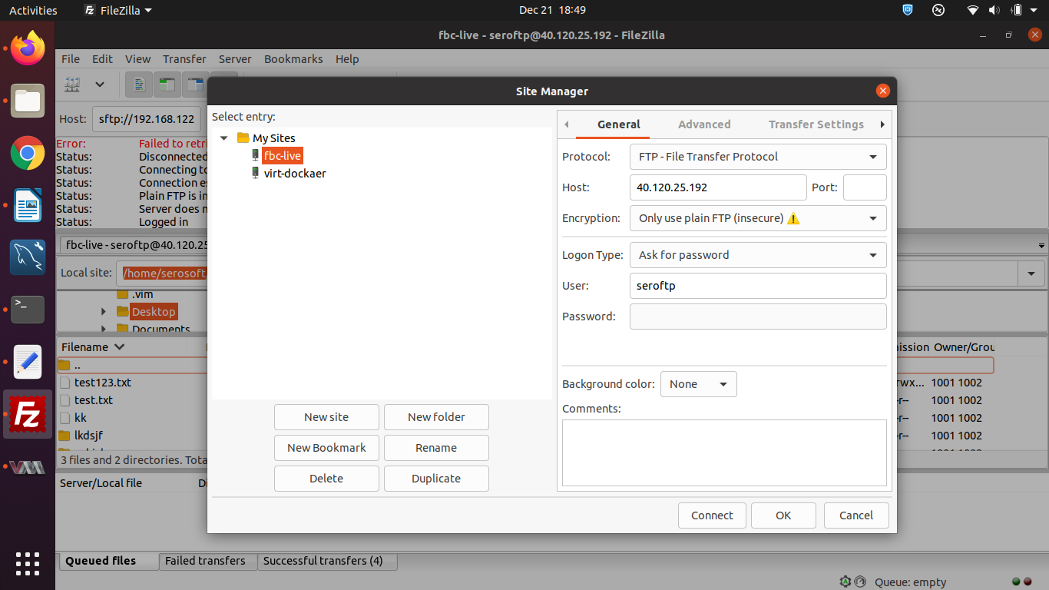**

**===other user create = for ftp only read access ===**

#adduser snjbftp

#echo "snjbftp" | sudo tee -a /etc/vsftpd.userlist

#systemctl restart vsftpd

**===== ssh === block ==== seroftp==== user =======**

add this live ::::: DenyUsers seroftp

/etc/ssh# vim sshd\_config

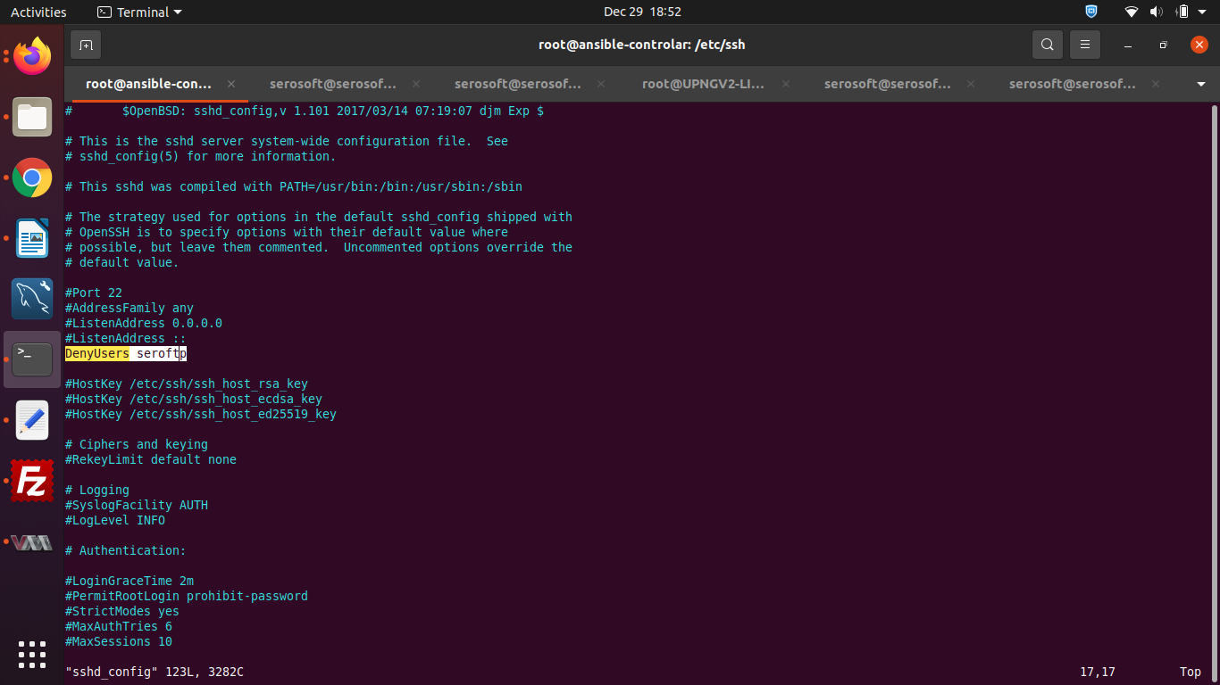

service ssh restart

service sshd restart

# ------------stricke bit ---- particular foldder access ==

#sudo chown username /folder

#sudo chown vinay /folder

# chmod 1777 /folder

#chmod +t /folder

# vinay ko /folder access ki permission h

Check it ----

ls -ld /folder

-------------------------

# “remove mysql from ubuntu 18.04 completely” Code Answer’s

sudo apt-get remove --purge mysql-server mysql-client mysql-common -y

$ sudo apt-get autoremove -y

$ sudo apt-get autoclean

rm -rf /etc/mysql

# Delete all MySQL files on your server:

sudo find / -iname 'mysql\*' -exec rm -rf {} \;

$ sudo apt-get remove --purge mysql-server mysql-client mysql-common -y

$ sudo apt-get autoremove -y

$ sudo apt-get autoclean

$ sudo rm -rf /etc/mysql

# Delete all MySQL files on your server:

$ sudo find / -iname 'mysql\*' -exec rm -rf {} \;

$ sudo apt-get remove --purge mysql-server mysql-client mysql-common -y

**=========mysql 8===========**

How to Install MySQL 8.0 on Ubuntu 18.04

s3r0s0ft

https://linoxide.com/linux-how-to/install-mysql-ubuntu/

https://linoxide.com/install-mysql-ubuntu/

**=== zip creater =====**

#sudo zip -r paymentprocess.zip paymentprocess

**====koha -- opac =====**

Open Terminal by pressing Ctrl + Alt + T (Press at a time)   
  
Step : 1 - Log in as superuser  
  
sudo su  
  
Enter root password  
  
Step : 2 - Update the system  
  
apt-get update

apt-get install mysql-server (only require mysql-server.5.7)

mysql -version

mysql -u ss\_root -p

sudo mysql\_secure\_installation

y

key values

0

new passwd

re enter

y

y

y

mysql -u root -p (for checking )

loging after change username

mysql> CREATE USER ‘ss\_root’@%’ IDENTIFIED BY ‘s3r0s0ft’;

mysql >GRANT ALL PRIVILEGES ON \*.\* TO ‘ss\_root’@’%’ WITH GRANT OPTION;

mysql> FLUSH PRIVILEGES;

exit

and check re-login

#mysql -u ss\_root -p

mysql > SET GLOBAL sql\_mode='';

Step : 3 - Upgrade the system  
  
apt-get upgrade  
  
step : 4 - Install MySQL server  
  
sudo apt-get install mysql-server  
  
Step : 5 - Check MySQL version  
  
mysql --version    
  
Step : 6 - Log in to MySQl  
  
mysql -u root -p  
  
Step : 7 - Set required permission  
  
SET GLOBAL sql\_mode='';  
  
Next exit  
  
Exit;  
  
  
Step : 8 - Update again the system  
  
apt-get update  
apt-get upgrade  
  
Step : 9 - Install lightweight text editor  
  
apt-get install leafpad  
  
Step : 10 - Add Koha community repository  
  
wget -q -O- http://debian.koha-community.org/koha/gpg.asc | sudo apt-key add -  
  
echo 'deb http://debian.koha-community.org/koha stable main' | sudo tee /etc/apt/sources.list.d/koha.list  
  
Step : 11 - Update again the system  
  
apt-get update  
apt-get upgrade  
  
Step : 12 - Install Koha  
  
apt-get install koha-common

**echo 'deb**[**http://debian.koha-community.org/koha**](https://www.google.com/url?q=http://debian.koha-community.org/koha&sa=D&source=hangouts&ust=1613281234146000&usg=AFQjCNFVRUUa9Mn__-kuUuxyRFsL6MBMWg)**stable main xenial' | sudo tee /etc/apt/sources.list.d/koha.list**

161  sudo apt install liblocale-codes-perl  
 162  sudo apt install liblocale-codes-perl\*  
 163  sudo perl -MCPAN -e 'install Bundle::KohaSupport'  
 164  sudo service apache2 restart  
 165  sudo perl -MCPAN -e 'install Class::Inspector'  
 166  sudo perl -MCPAN -e 'install Net::Stomp'  
 167  sudo perl -MCPAN -e 'install Email::Sender'

apache2 – logs

sudo tail -100 /var/log/apache2/access.log

sudo tail -100 /var/logs/apache2/error\_log

[http://libtechbwn.blogspot.com/2018/09/install-koha-in-ubuntu-1804-lts.html](https://www.google.com/url?q=http://libtechbwn.blogspot.com/2018/09/install-koha-in-ubuntu-1804-lts.html&sa=D&source=hangouts&ust=1617978355098000&usg=AFQjCNEmYqYHCzQUk3jxL0uYyQIcMVCCsA)  
  
Issue resolved  
  
[http://koha.1045719.n5.nabble.com/Error-accessing-quot-About-Koha-quot-after-the-upgrade-20-5-td6088651.html](https://www.google.com/url?q=http://koha.1045719.n5.nabble.com/Error-accessing-quot-About-Koha-quot-after-the-upgrade-20-5-td6088651.html&sa=D&source=hangouts&ust=1617978355098000&usg=AFQjCNFSdAk0KdCj4OgQTUt4n2iw0evhgw)  
  
sudo apt install libcpan-meta-requirements-perl

ubuntu 16.04 me issue aaye

to ye command chala dena

**echo 'deb** [**http://debian.koha-community.org/koha**](https://www.google.com/url?q=http://debian.koha-community.org/koha&sa=D&source=hangouts&ust=1624715909451000&usg=AFQjCNH6I7P5eMO7cLOEeNfxzoAQbU7XFw) **stable main xenial' | sudo tee /etc/apt/sources.list.d/koha.list**

**ubuntu 18.04 me issue aaye to**

**echo 'deb** [**http://debian.koha-community.org/koha**](https://www.google.com/url?q=http://debian.koha-community.org/koha&sa=D&source=hangouts&ust=1624715955244000&usg=AFQjCNGNy1Nf9H6LHll1-UaqnREtHjeQGg) **stable main b**ionic**' | sudo tee /etc/apt/sources.list.d/koha.list**

***Search a Content in a text file***

*open file press Esc and :/port (first press “enter” after press “n”)*

*:set nu (number line)*

--date wise --

ll | grep 'May 28'

---

find /home/serosoft/ -size 10M

find /home/serosoft/ -size +10M

find /home/serosoft/ -size -10M

find /home/serosoft/ -size 100M

find /home/serosoft/ -size +50M -size -80M (between 50 to 80M)

--- user base search (vinay)

find / -user vinay

find / -user vinay -exec cp -rf {} **data** \;

(vinay all userdata copy to data directory)

*grep -in listener catalina.2021-10-14.log >* ***text***

*=================*

======= logs time === wise ==== find == grep =====

-- in file

grep -Rin **Listener** catalina.2021-10-14.log (with directory)

grep -in **listener** catalina.2021-10-14.log

grep -in **pooja** /home/serosoft/Desktop/virt

---

#find **/home/serosoft/Documents/Jar/** "Sep 23" -exec cp -rf {} **data** \;

------

=============== logs time === wise ===========

grep -n "2021-06-02 15:" catalina.out

grep "2021-08-13 11:" msg.UserTriggeredMsgQueueListenerLogger-debug.log

to check how many files in any folder  
ls | wc -l

grep -in 'Oct 16 16:' /var/log/apache2/error.log

grep -in "Oct 14, 2021 6:33" catalina.2021-10-14.log

grep -in "Oct 14, 2021 4:" catalina.2021-10-14.log

====================>>>>>>>>>>>>

grep -in "2022-02-02 14:" catalina.out

grep -in "2022-02-02 15:" catalina.out

sed -n -e '1263781,1293568p' catalina.out > catlinalog\_2feb.txt

=======================>>>>>>>>

grep -in "feb 02, 2022 3:" catalina.out

grep -in "2022-02-02 14:" catalina.out

sed -n -e '1263781,1293568p' catalina.out > catlinalog\_2feb.txt

+++++++++++++++++++

grep -in "2022-02-02 14:" catalina.out

-------

grep -n "2021-06-02 15:" catalina.out

grep "2021-08-13 11:" msg.UserTriggeredMsgQueueListenerLogger-debug.log

*to check how many files in any folder  
ls |wc -l*

*to check how many files in any folder  
ls |wc -l  
  
serach content in multiple file  
grep -E -R 'demo20' \*.conf  
  
check log of spcific time (with line no.)  
grep -n "2019-04-09 14:" catalina.out  
  
copy line no to line no word from old file to new file  
sed -n -e '10,100p' catalina.out > output.txt  
  
find file name by date  
l |grep msg.SmsQueueListenerLogger-debug.log | grep 'Sep 19'  
  
find all files by date  
ll | grep 'Sep 19'*

*ll | grep 'FinanceDataforSageX3.log'*

*================*

***Search a Content in a text file***

*open file press Esc and :/port (first press “enter” after press “n”)*

*:set nu (number line)*

*---------------------*

*#find / -name CGPASGPAJobLogger*

*sudo find v2\_uploads/ -iname 'kies\_20221616624562.pdf'*

*sudo find /opt/serosoft/v2\_uploads/basedir/\* -iname 'sssfsf1633008260941.pdf'*

ls -lart | grep "Yuvraj Singh1623062846290.pdf"

find / -iname temp

find / -iname competitive589

***==== +10 +30 data remove ===***

***#find /var/log -name "\*.log" -type f -mtime +30 -exec rm -f {} \;***

*find /opt/serosoft/db\_backup/ -type d -mtime +60 -exec rm -rf {} \;*

*command do delete 30days old files* find . -mtime +30 -exec rm {} \;

command do delete 30days old files

find . -mtime +30 -exec rm {} \;

*======= multiple file cp one directory=========*

*find . -name 'Finance data for sage x3 program\*' -exec cp -rfp {} /home/seroadmin/23dec/ \;*

**---------- donot – run this cmd ===------------------delet 100M files-----**

**find . -size +100M -delete**

***=========>>>>>>>>>>***

**=== content change ==**

*sudo sed -i 's/'ss\_root'/'prod\_root'/g' autest.txt*

***replace the content without open file***

*#sudo sed -i 's/'ss\_root'/'prod\_root'/g' autest.txt*

*replace the content with open file*

*:% s/anantu.academiaerp.com/academia.anu.edu.in/gi*

*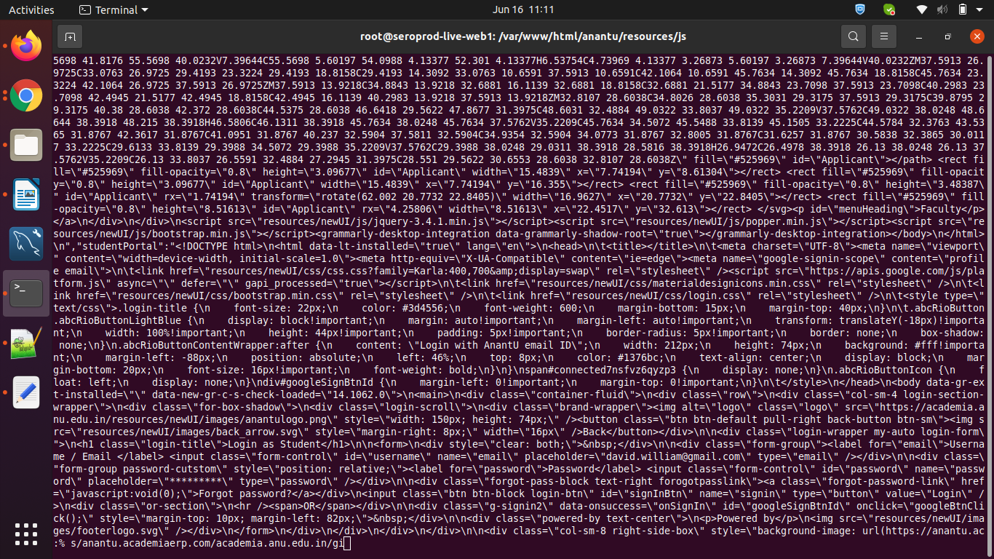*

**===run two command ==**

sudo chown -R www-data:www-data enquire && sudo chmod -R 755 enquire

**==== app\_cerp file change =====**

**1- login instance**

**2- take backup old file**

**#cd /var/www/html/collegetest (changeing file location)**

**3-copy date on server**

**#scp -r app\_cerp** [devadmin@imt-marketing.centralindia.cloudapp.azure.com](http://imt-marketing.centralindia.cloudapp.azure.com/)**:/home/devadmin**

**4- after then copy correct location**

**#cd */var/www/html/collegetest***

**5- change permission**

**# sudo chmod 755 app\_cerp.js**

**6-sudo chown www-data:www-data app.cerp.js**

**7- change version (all app.js file change version increase 1 poit)**

**#sudo vi index.html**

**(var currentVersion = 1)**

**8- review and submit**

**==== Deploy faculty protal director change =====**

*1- login instance*

*2- take backup old file*

*#cd /var/www/html/collegetest (“faculty\_portal” changeing file location)*

*# sudo cp -r faculty\_portal faculty03DecBackup*

*3-copy date on server*

*#scp -r facutly\_portal* [*devadmin@imt-marketing.centralindia.cloudapp.azure.com*](http://imt-marketing.centralindia.cloudapp.azure.com/)*:/home/devadmin*

*4- after then copy correct location*

*#cd /var/www/html/collegetest*

*5- change permission*

*# chmod 755 facutly\_portal*

*6-chown www-data:www-data facutly\_portal*

*8- review and submit*

**==== take log file change =====**

**1- login instance**

**#ps -ef | grep tomcat (which tomcat runing atfter go to path)**

**2- #cd /opt/serosoft/erp\_tomcat-7/logs**

**3- #tail -f catlina.out**

**(after ping to person say hit atfer log generat and copy past on mail body send)**

**4-done it.**

**==== take dump (mysql\_dump) =====**

**1- login instance**

**2- #mysql -u ss\_root -p (s3r0s0ft)**

**check the database**

**> show databases; (having or not)**

**>exit**

**3- backup on present location**

**#mysqldump --user=ss\_root --host=localhost –pa ssword --routines --events --databases  --set-gtid-purged=OFF “collegetest” “collegetest\_audit” > collegetest\_withaudit.sql**

**4- create zip file from backup**

**#zip collegetest\_withaudit.sql.zip collegetest\_withaudit.sql**

**4 – move to perticular directory**

**#sudo mv collegetest\_withaudit.sql.zip /var/www/html/collegetes**

**5- create link and send person**

**(**[**https://collegetest.academiaerp.com/collegetestswith\_audit22novback.sql.zip**](https://collegetest.academiaerp.com/collegetestswith_audit22novback.sql.zip)**)**

**6- done**

**==== class file change =====**

**1- login instance**

**2- take backup old file**

**#cd** /home/serosoft/sero/installation/erp\_demo\_tomcat/webapps/aus\_demo/WEB-INF/lib/ **(changeing file location)**

**#scp -r devadmin@sisstagingvm.centralindia.cloudapp.azure.com:/opt/serosoft/tomcat\_sunshine/webapps/testing\_sunshine/WEB-INF/lib/serosoft-academia-common-1.0-SNAPSHOT.jar .**

**Copy to server location**

#scp -r serosoft-academia-service-1.0-SNAPSHOT.jar serosoft@114.143.176.181:/home/serosoft/sero/installation/erp\_demo\_tomcat/webapps/aus\_demo/WEB-INF/lib/

serosoft@AUSERPDEMO:~/sero/installation/erp\_demo\_tomcat/webapps/aus\_demo/WEB-INF/lib$ kill -9 30444

serosoft@AUSERPDEMO:~/sero/installation/erp\_demo\_tomcat/webapps/aus\_demo/WEB-INF/lib$ ps -ef | grep tomcat

/sero/installation/erp\_demo\_tomcat/bin$ ./startup.sh

/sero/installation/erp\_demo\_tomcat/logs$ tail -f catlina.out

(showing tomcat start – check)

**==== drool\_rule Directory change =====**

**1- login instance**

**2- take backup old file**

**#cd /opt**/serosoft/sero/installation/erp\_demo\_tomcat/webapps/aus/resours/WEB-INF/classes/ **( “drool\_rules” changeing file location)**

**#sudo cp -r drool\_rules drool\_rules03DecBackup**

**Copy to server location ::**

#scp -r drool\_rules serosoft@114.143.176.181:**/opt**/serosoft/sero/installation/erp\_demo\_tomcat/webapps/aus/resours/WEB-INF/classes/

serosoft@AUSERPDEMO:~/serosoft/installation/erp\_demo\_tomcat/webapps/aus\_demo/WEB-INF/lib$ kill -9 30444

serosoft@AUSERPDEMO:~/sero/installation/erp\_demo\_tomcat/webapps/aus\_demo/WEB-INF/lib$ ps -ef | grep tomcat

/sero/installation/erp\_demo\_tomcat/bin$ ./startup.sh

/sero/installation/erp\_demo\_tomcat/logs$ tail -f catlina.out

(showing tomcat start – check)

**==== jasperTemplates change =====**

**1- login instance**

**2- take backup old file**

**3-**ps -ef | grep tomcat (which tomcat running )

**#cd /opt**/serosoft/sero/installation/erp\_demo\_tomcat/webapps/aus/resours/ >> jasperTemplates **(changeing file location)**

**Copy to server location**

#scp -r serosoft-academia-service-1.0-SNAPSHOT.jar serosoft@114.143.176.181:**/opt**/serosoft/sero/installation/erp\_demo\_tomcat/webapps/aus/resours/jasperTemplate

**--- Data transfer with port number ----**

1-

#scp -P 26 [server@136.23230.22](mailto:server@136.23230.22):/opt/serosoft .

(server to local PC)

2-

#scp -P 26 app\_cerp.jar [server@136.23230.22](mailto:server@136.23230.22):/opt/serosoft

(local PC to server)

**--- Data transfer with port number ----**

|  |  |
| --- | --- |
| Check timezone  timezone set | #timedatectl  timedatectl set-timezone Asia/Ho\_Chi\_Minh    timedatectl set-timezone Europe/Berlin  sudo timedatectl set-timezone Asia/Kolkata |
| Check thred dump | #ps -ef | grep tomcat (first check tomcat)  # jstack -l (pid\_tomcat) >> trhreaddump.log |
| Check the last file | #ls -ltr |
| Mysql dump | #**mysqldump --user=ss\_root --host=localhost --password --routines --events --databases  --set-gtid-purged=OFF “collegetest” > collegetest.sql**  **after zip**  **#zip collegetest.sql.zip collegetest.sql**  **after give it create link**  **mysql dump command**  **mysqldump -u username -p dbname > filename. sql** |
| Remote dump - backup | mysqldump --user=ss\_root --host=102.133.235.66 --password --routines --events --databases --set-gtid-purged=OFF "buzz" "buzz\_audit" > buzz\_15102021.sql |
| Os trableshooting | #free -h  #sync; echo 1 > /proc/sys/vm/drop\_caches  #sync; echo 1 > /proc/sys/vm/drop\_caches |
| Mysql database : connection flush | mysql>FLUSH HOSTS; |
| Database drop  database create | mysql>DROP DATABASE database\_name;  #mysqladmin -u root -p drop database\_name  mysql> CREATE DATABASE blog; |
| Database import | mysqldump -u username -p database\_name > data-dump.sql  7987684  #mysql -u ss\_root -p < serosoftwithaudit.sql  done on db set global max\_connections=4100; set global max\_user\_connections=400;  SHOW STATUS WHERE `variable\_name` = 'Threads\_connected'; SELECT User, Host, max\_connections, max\_user\_connections FROM mysql.user;  SET GLOBAL max\_connections = 50000;  SHOW VARIABLES LIKE "max\_connections"; |
| Database select | Mysql > use pgi; |
| Check disk space | #df -hT /\*  #du -sh  df -ah  lsblk  fdisk -l  1972 du -sh catalina.out  1973 cat /dev/null > catalina.out  1974 du -sh catalina.out  1975 df -h |
|  | mysql -u ss\_root -p < serosoftwithaudit.sql |
| Database import with pv command show % database | pv serosoftwithaudit.sql | mysql -u ss\_root -p |
|  | mysql -u academia\_ss\_wp -p academia\_gvfw1\_new < academia\_gvfw1\_new.sql |
|  | pv create.sql | mysql -u root -p zabbix |
| Mysql version | mysql -V |
| Database check | grep 'CREATE DATABASE' iihmr17decbackup.sql |
|  |  |
| Database name change in database.sql file | sed -i 's/`iihmr`/`iihmr\_demo`/g' iihmr17decbackup.sql |
|  | sed -i 's/`iihmr\_audit`/`iihmr\_demo\_audit`/g' iihmr17decbackup.sql |
|  |  |
|  | select \* from schema\_version; |
|  | SELECT \* FROM schema\_version where success=0; |
| Sleep connection | show processlist;  SET GLOBAL interactive\_timeout = 180;  SET GLOBAL wait\_timeout = 180; |
| Jenkins == views issues | SELECT \* FROM information\_schema.views; |
|  |  |
|  |  |
| Remote loging | mysql -u ss\_root --host=192.168.1.1 -p |
| Tomcat to db connection check | telnet 172.0.2.5 3306 |
| Port check | ss -tnlp |
| User create and persmmision | mysql> create user 'powerbi'@'%' identified by 'serosoft#123'; Query OK, 0 rows affected, 1 warning (0.01 sec)  mysql> grant all privileges on ugi.\* to 'powerbi'@'%'; Query OK, 0 rows affected (0.00 sec)  mysql> grant all privileges on ugi\_audit.\* to 'powerbi'@'%'; Query OK, 0 rows affected (0.01 sec)  mysql> flush privileges; Query OK, 0 rows affected (0.01 sec) |
|  | show variables like 'port'; |
|  | DB Access and Revoke   1. Login Mysql Database 2. Show grants for ‘serosoft’; (serosoft is a user, To  see the permission of user) 3. REVOKE SELECT on vgu.student\_list\_view FROM ‘serosoft’@’%’; (permission, DBname.teblename, user) 4. Show grants for ‘serosoft’; (to verify table name remove or not) 5. GRANT SELECT ON vgu.vgu\_student\_list\_view TO 'serosoft'@'%'; (Provide access to the table) 6. Show grants for ‘serosoft’; (For check - New table ka access mila) 7. flush privileges; (To apply changes) |
| ss\_root ko check karna | select \* from mysql.user\G |
|  | select \* from mysql.user where user = 'ss\_root'\G |
| ss\_root passwd reset | ALTER USER 'ss\_root'@'localhost' IDENTIFIED BY 's3r0s0ft'; |
|  | ALTER USER 'ss\_root'@'%' IDENTIFIED BY 's3r0s0ft'; |
| Mysql passwd expiry | CREATE USER 'somesh'@'localhost' IDENTIFIED BY 's3r0s0ft' PASSWORD EXPIRE INTERVAL 01 DAY; |
|  | SELECT user, host, password\_lifetime, password\_expired, password\_last\_changed FROM mysql.user WHERE user = 'somesh'\G |
|  | SELECT user, host, password\_lifetime, password\_expired, password\_last\_changed FROM mysql.user WHERE user = 'somesh'; |

**=== database ka size ======== run in mysql terminal ==**

SELECT table\_schema AS 'DB Name', ROUND(SUM(data\_length + index\_length) / 1024 / 1024, 1) AS 'DB Size in MB' FROM information\_schema.tables GROUP BY table\_schema;

**================ drop mysql user ====================**

SELECT User, Host FROM mysql.user;

DROP USER 'username'@'host';

DROP USER 'ved'@'%';

**---=========Database Access ======= ----**

**1- open mysql work bench**

**2- add connection >>>**

**3- user and privileges >> add account**

**4- schema privileges >> add entry >>selected schema >> salecte all >> apply >> ping user details**

**Hostname ::**

**userid :: bhagwans**

**passwd :: Bhagwan@123**

**database name :: schooltest, schooltest\_audit**

**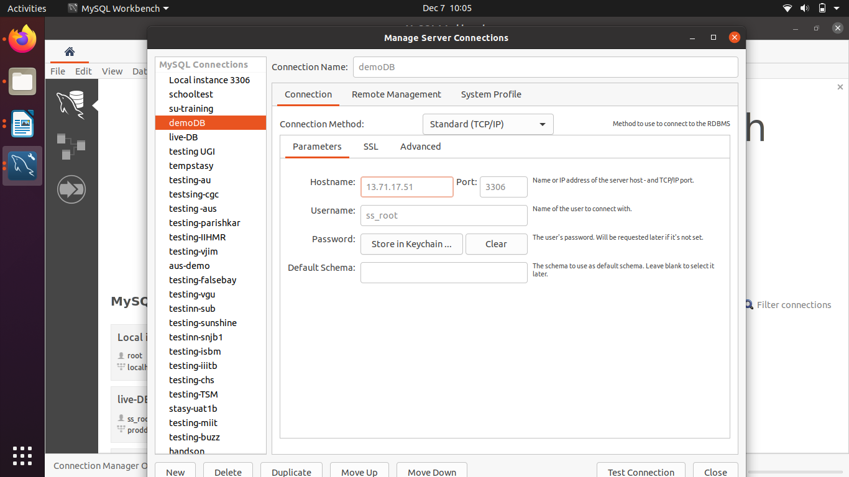**

**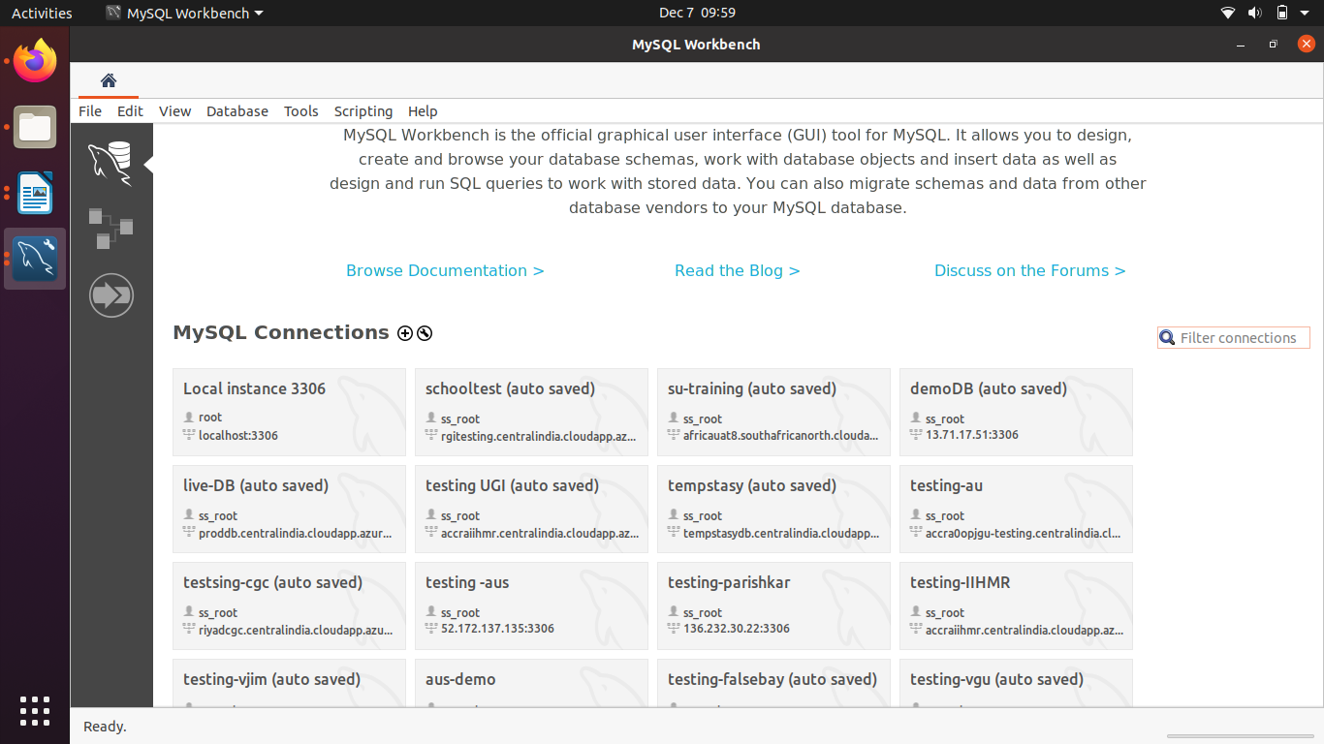**

**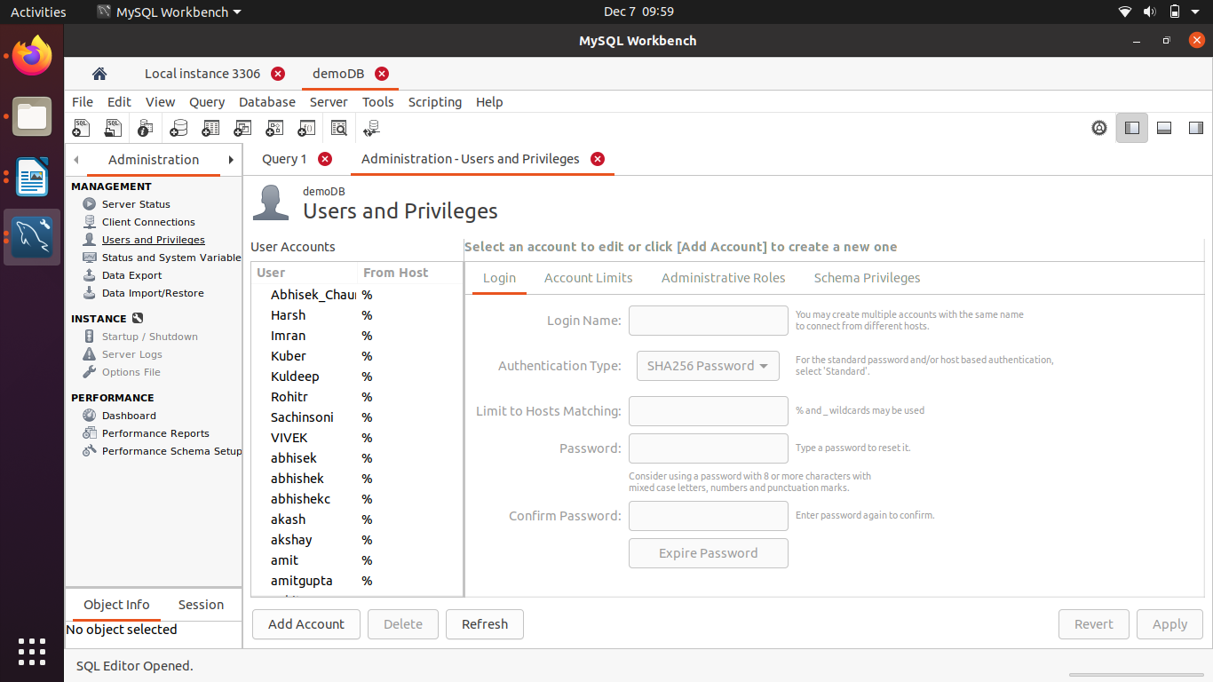**

**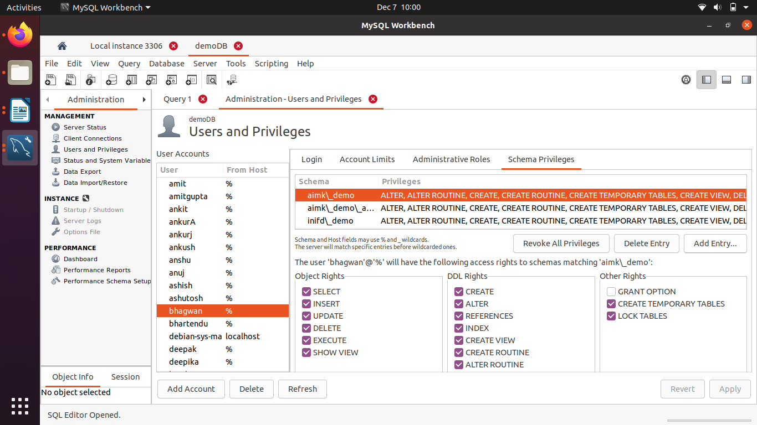**

**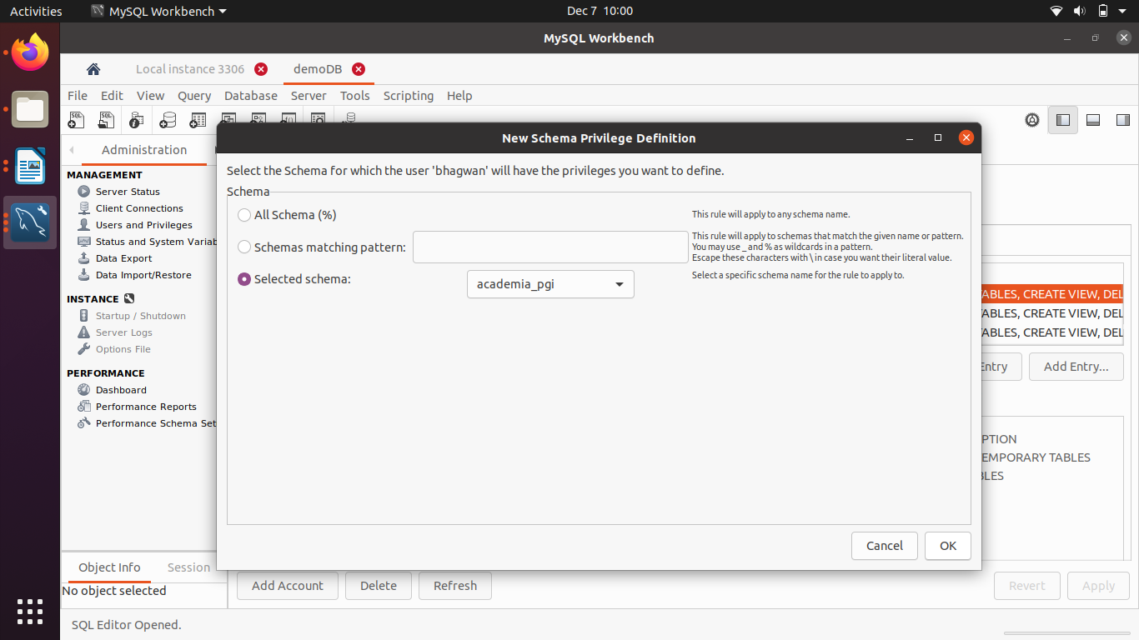**

**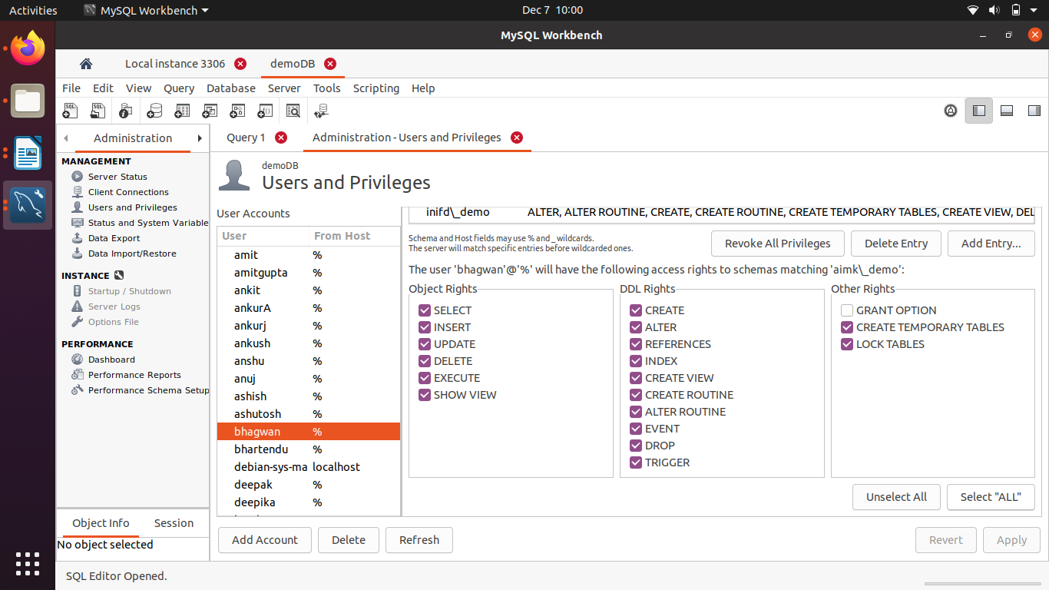**

**---=========Build update process ======= ----**

**||||||||||||||||||| web server |||||||||||||||||||||||||||||**

**1-login web server**

**2- go #cd** cd /var/www/html/

3- create a backup folder (with instance\_name\_09\_dec\_2020)

ex. >>>>> rgi\_09dec20

4- go to intance folder #cd rgi

5- move all content to backup folder >>> #sudo mv \* ../rgi\_09dec20/

6-go to maintant folder

#cd */var/www/html/maintain*

*7-copy all content to instance folder (rgi)*

*# sudo cp -r \* ‘/var/www/html/rgi/*

*tomcat*

*1- login*

*2- kill the tomcat #kill -9 Process\_id*

*3- create a backup folder*

*#mkdir /opt/serosoft/oldwar/08dec*

*3- go to tomcat*

*#**cd /opt/serosoft/tomcat\_rgi\_demo/webapps*

*4- move to war file to backup folder*

*#mv war files /opt/serosoft/oldwar/08dec/*

*5-*

***||||||||||||||||||| database |||||||||||||||||||||||||||||***

***1- take mysql database dump (rgitest, rgitest\_audit)***

*#****mysqldump --user=ss\_root --host=localhost --password --routines --events --databases  --set-gtid-purged=OFF “rgitest” “rgitest\_audit” > rgitestwithaudit.sql***

***2- move to database backup to jenkins***

***(#cd )***

***>>>>> jenking step >>>>>>>>>>***

***1- login jenkins***

***2- drop the database same if name is same***

***3- import new database***

***4- open jenkins url and login***

***5- go to code checkout 1***

***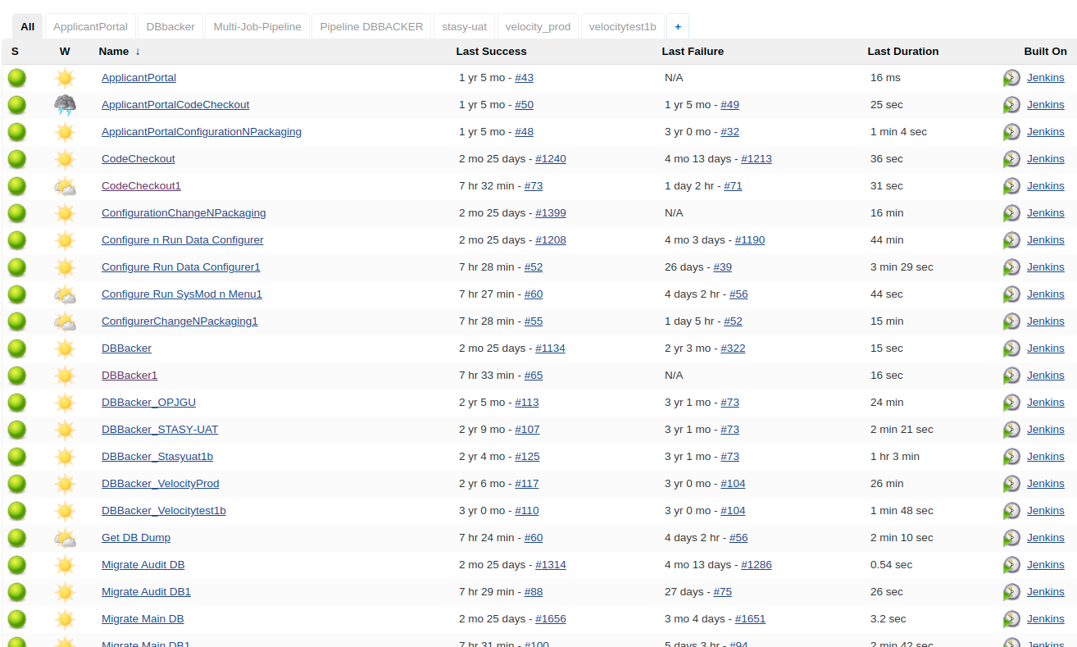***

***6- click on code checkout1 >>> configure >>> insert the tage git bucket***

***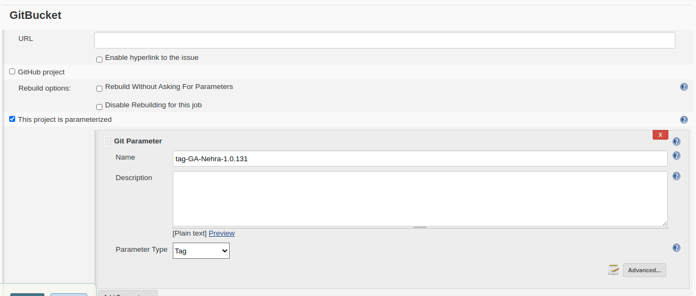***

***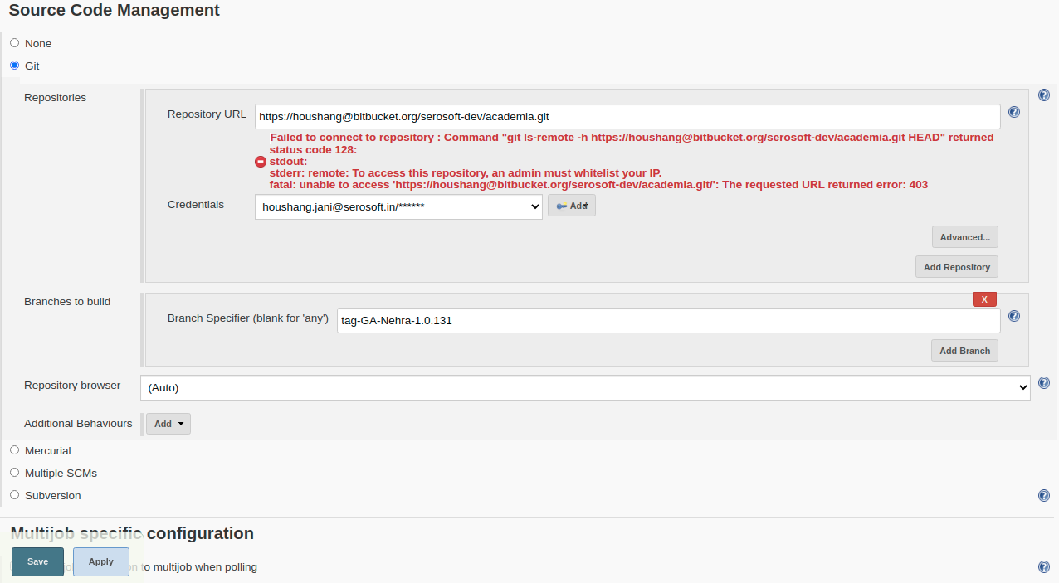***

***7- click apply and save***

***8- click on jenkins menu >>>> DBBacker1 >>>*** [***Build with Parameters***](http://pocjenkins.centralindia.cloudapp.azure.com:19080/jenkins/job/DBBacker1/build?delay=0sec)

***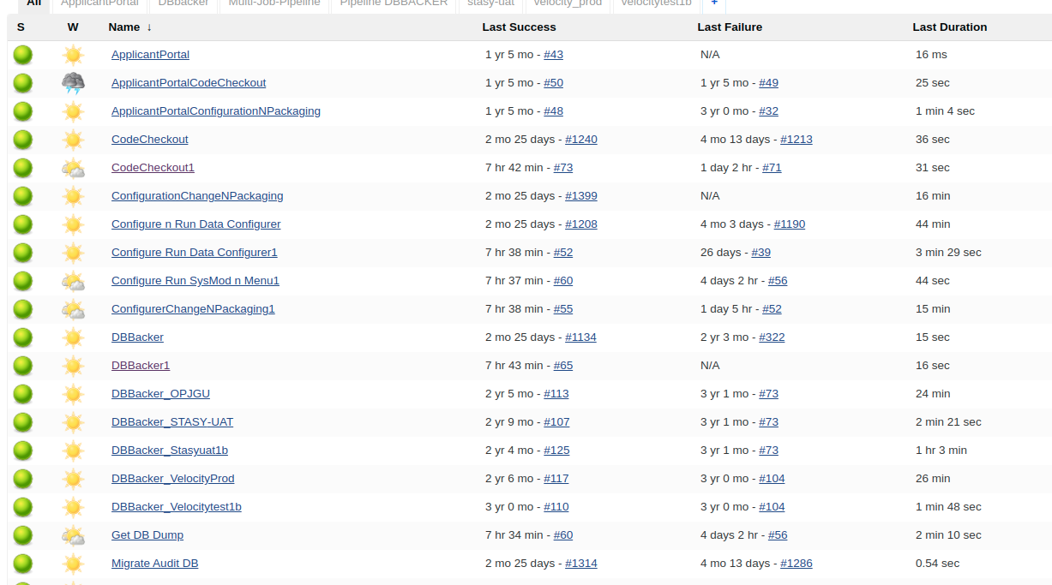***

***9- click on Buil with parameter***

***click on jenkins menu >>>> DBBacker1 >>>*** [Build with Parameters](http://pocjenkins.centralindia.cloudapp.azure.com:19080/jenkins/job/DBBacker1/build?delay=0sec)

***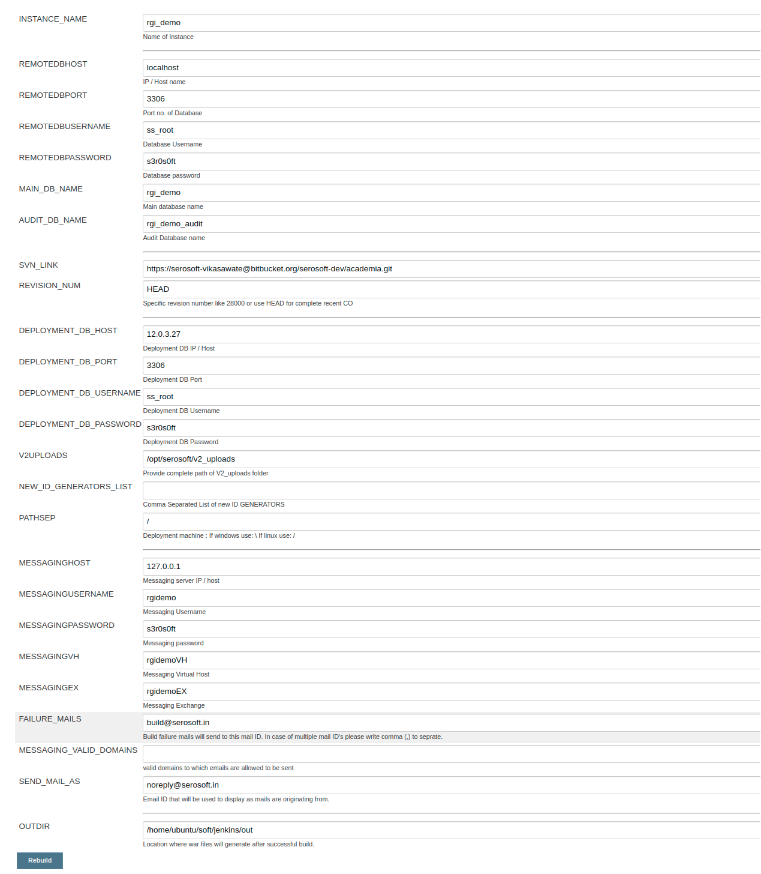***

***10 -data location which one you entry***

***#cd ‘/opt/serosoft/apache-7.0.94/webapps/MSG\_falsebaydemo/WEB-INF/classes/config/***

1-database.properties

2-document-constant.properties

3-massaging.properties

(check data and fill entry)

***dont have MSG\_falsebaydemo***

***go to tomcat server***

#cd /opt/serosoft/tomcat9/webapps/falsebay\_demo/WEB-INF/lib/serosoft-academia-service-1.0-SNAPSHOT.jar

***take this jar file local pc and open go to***

***config >***

1-database.properties

2-document-constant.properties

3-massaging.properties

(check data and fill entry)

***11 – re-build***

***go to jenkins home > Multi-Job-Pipeline/***

***for laptop vpn connection***

***ip == 183.182.84.235***

***port == 5443***

***userid***

***passwd***

***Username someshwarV***

password Vinay#456

***12- vpn connection in jenkins***

**l**ogin jenkins

#cd ‘/home/labadmin

#cd /forticlientsslvpn/64bit

#sudo ./forticlientsslvpn\_cli --server 183.182.84.235:5443 --vpnuser someshwarV

enter vpn user and passwd

press y

username someshvinay

password Vinay^789

***it’s show sucees then “your process success”***

***build fail condition check jenking space have or not than free space at 5GB and pend on sql file size***

***go to failed option check the log which resone fail it***

***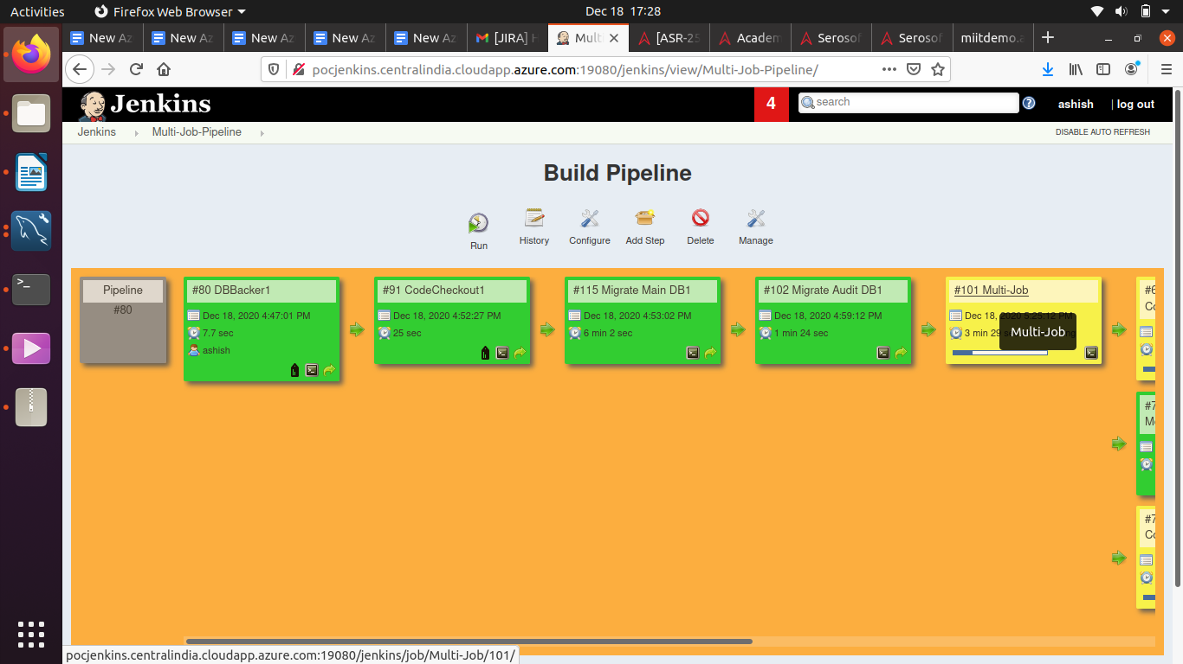***

***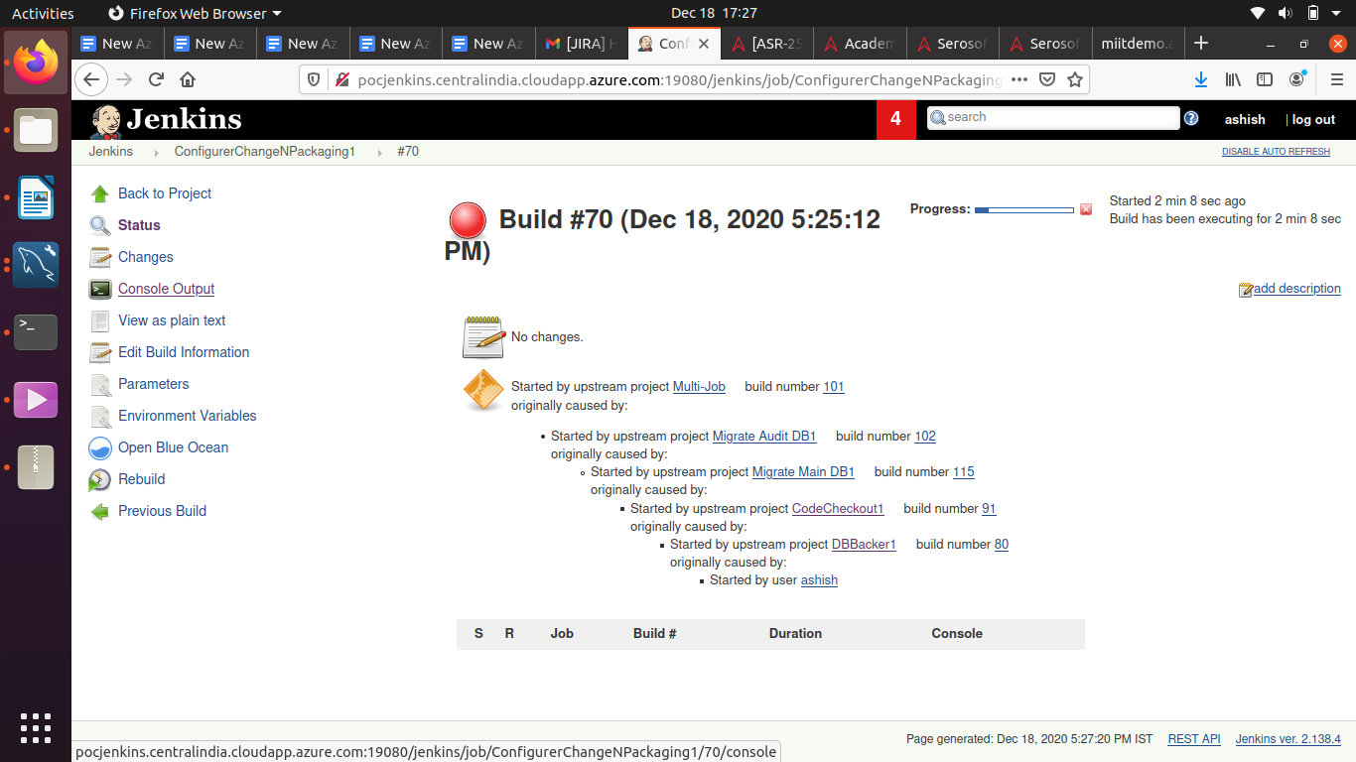***

***=====Data out location====***

***13-****copy data to database server and import to new database*

***# cd /home/ubuntu/soft/jenkins/out***

*copy data to database server and import to new database*

*drop the database #*

*mysql> drop databse miit\_demo;*

*mysql> drop databse miit\_demo\_audit;*

#pv miit\_demo18dec.sql | mysql -u ss\_root -p (database import)

***14 -copy data from jenkins to tomcat app server***

***# cd /home/ubuntu/soft/jenkins/out***

*1-miit\_demo\_2020\_12\_21\_12\_32\_56.war*

*2-MSG\_falsebay\_demo\_2020\_12\_21\_12\_32\_56.war*

***15 - take older files & folder backup (miit\_demo18decbackup)***

***copy this “.war” file------------***

*1-miit\_demo\_2020\_12\_21\_12\_32\_56.war*

*2-MSG\_falsebay\_demo\_2020\_12\_21\_12\_32\_56.war*

***16- re-name “.war” file***

*#sudo mv miit\_demo\_2020\_12\_21\_12\_32\_56.war miit\_demo.war*

*#sudo mv MSG\_miit\_demo\_2020\_12\_21\_12\_32\_56.war MSG\_miitdemo.war*

*17 -after start tomcat*

*#cd /opt/serosoft/tomcat\_miit\_demo/bin*

*# ./start.sh*

*#cd /opt/serosoft/tomcat\_miit\_demo/logs*

*#tail -f catlina.out (for check tomcat up or donw)*

18 -take the main file “miit\_demo” and copy to web server

**19- v2\_uploads-----------**

*#cd /opt/serosoft/v2\_uploads (jenkins path)*

***v2\_uploads file copy from jenkins to web server*** *copy all file to web server in miit\_demo*

**20- copy logo-----------**

***#cd /var/www/html/miit\_demo\_18Dec/resources/images/newUI***

*#sudo cp aditech\_logo.png stasylogo.png /var/www/html/miit\_demo/resources/images/newUI/*

**21- NOT ::: special condition**

*older folder have in* ***paymentprocess***

***#cd /var/www/html/miit\_demo***

*#sudo vi buildInfo.xml*

*change ==== “localhost” to “*[*https://miitdemo.academiaerp.com/*](https://miitdemo.academiaerp.com/)*”*

<paymentUrl>**http://localhost**/paymentprocess/payu-enterprise-doTransaction-using-soap.php</paymentUrl>

*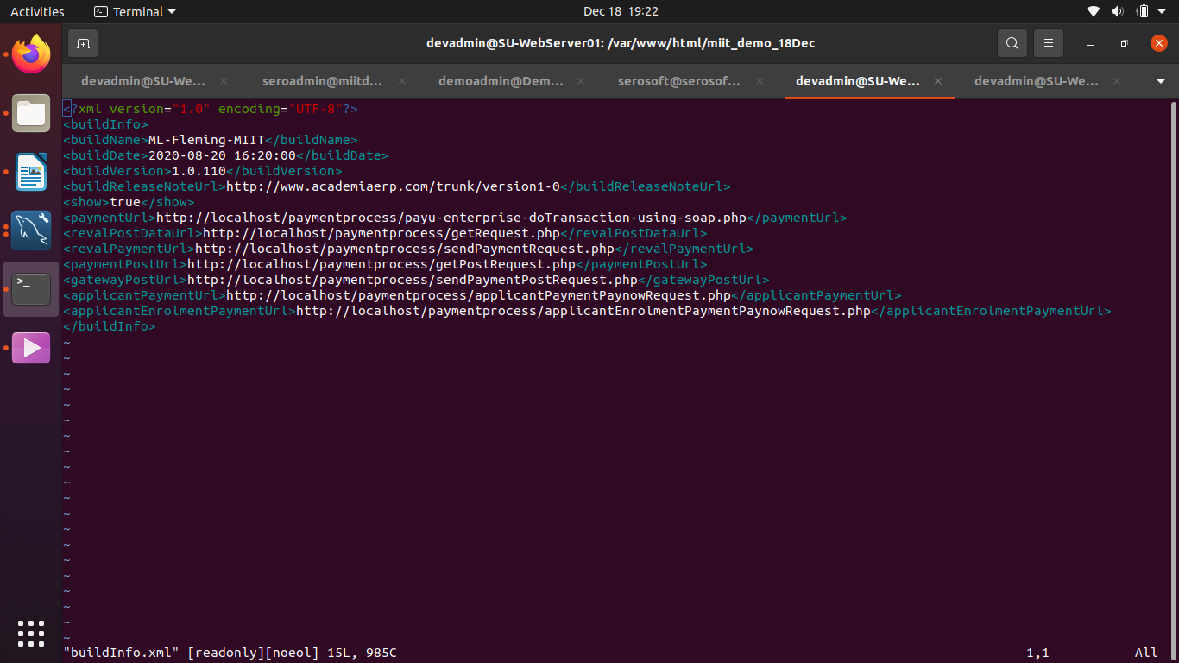*

**22 - others--------**

***copy other folder from old miit\_demo\_18dec to new miit\_demo***

***23- after give permission***

***#****cd ‘/var/www/html/*

*#sudo chmod -R 755 miit\_demo*

*#sudo chown -R www-data:www-data miit\_demo*

*after all proces done and mail it all detail instance*

***Live database to demo db convert, run this qurey***

**Database updated script (When Demo instance will update with live DB)**

*update external\_users set* [*emailId='serosoft.qa1@gmail.com*](mailto:emailId%3D'serosoft.qa1@gmail.com)*' where id>0;  
update users set* [*emailId='serosoft.qa1@gmail.com*](mailto:emailId%3D'serosoft.qa1@gmail.com)*' where id>0;  
update persons set* [*alternateEmailId='serosoft.qa1@gmail.com*](mailto:alternateEmailId%3D'serosoft.qa1@gmail.com)*' where id>0;  
update persons set* [*emailId='serosoft.qa1@gmail.com*](mailto:emailId%3D'serosoft.qa1@gmail.com)*' where id>0;  
update persons set mobileNumber='1234567890' where id>0;  
update applicant\_person set* [*alternateEmailId='serosoft.qa1@gmail.com*](mailto:alternateEmailId%3D'serosoft.qa1@gmail.com)*' where id>0;  
update applicant\_person set* [*emailId='serosoft.qa1@gmail.com*](mailto:emailId%3D'serosoft.qa1@gmail.com)*' where id>0;  
update applicant\_person set mobileNumber='1234567890' where id>0;  
update persons set alternateMobileNo=null where id>0;  
update persons set phoneNo='1234567890' where phoneNo is not null;  
update enquiry set primaryeEmailId ='*[*serosoft.qa1@gmail.com*](mailto:serosoft.qa1@gmail.com)*', phoneNo='1234567890', alternatePhoneNo = null where id>0;  
UPDATE `fee\_payer\_detail` SET `homeTelephoneCountryCode`='+27', `homeTelephone`='1234567890', `workTelephoneCountryCode`='+27', `workTelephone`='1234567890', `mobileNumber`='1234567890', `*[*emailHome`='serosoft.qa1@gmail.com*](mailto:emailHome%60%3D'serosoft.qa1@gmail.com)*',* [*`emailWork`='serosoft.qa1@gmail.com*](mailto:%60emailWork%60%3D'serosoft.qa1@gmail.com)*'****;***

***last line not run to run this last qurey***

***open new tab and run***

*SET SQL\_SAFE\_UPDATES = 0;*

***after all qurey run again***

***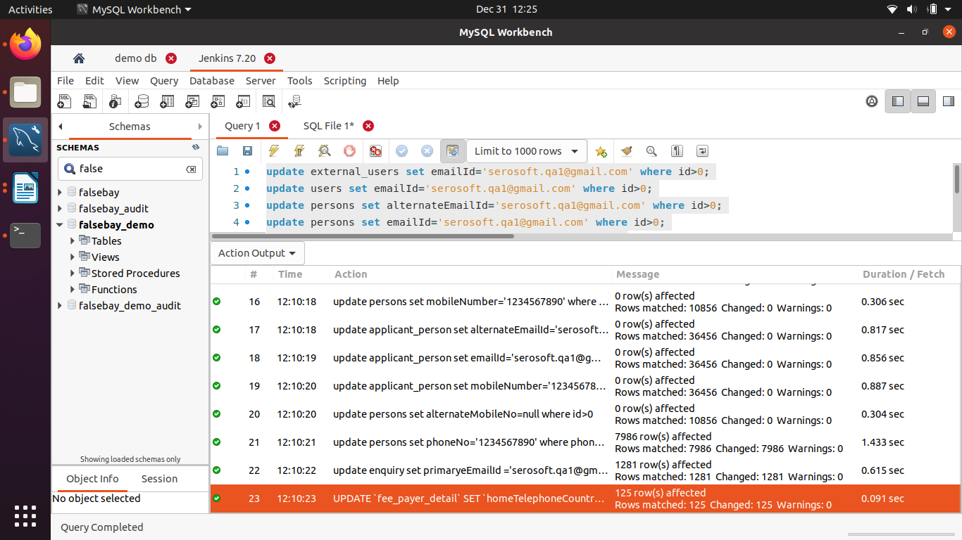***

***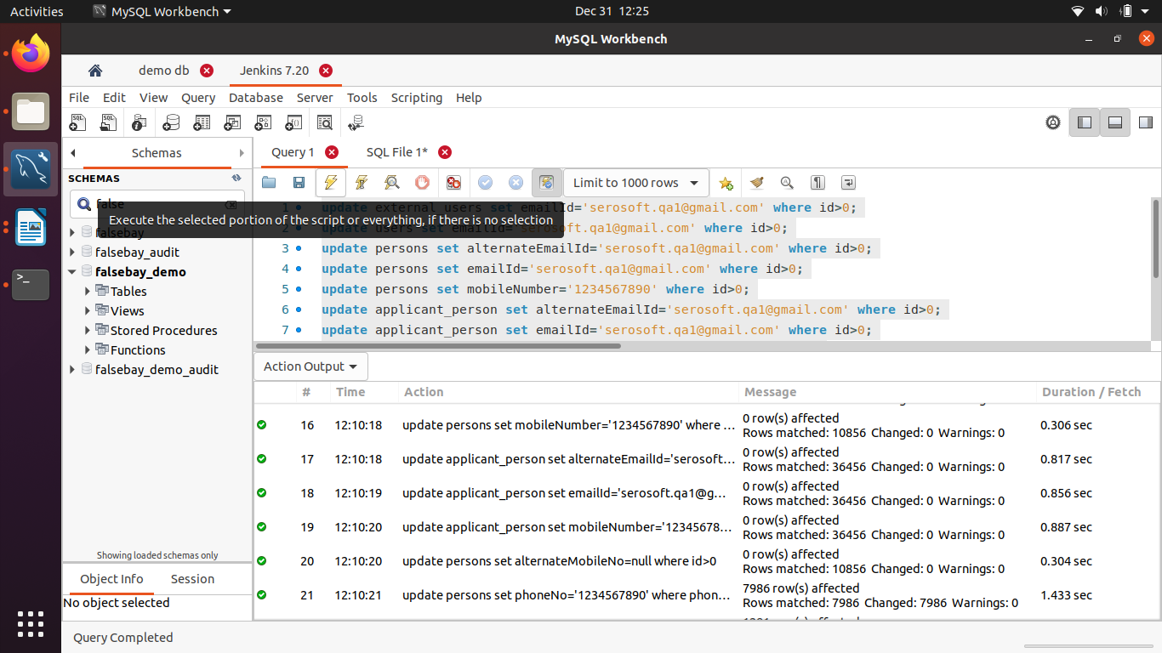***

***+++++++++++++++End build process ++++++++++++++++++***

***old db – database 5.6 to convert new db database 8.00***

***run this query in old db and taking dump and go ahead***

***Please execute this query on all clients db on mysql 5.6.***

|  |
| --- |
| ALTER TABLE `course\_variant\_subType\_ DROP INDEX `subType\_mapping\_unique\_ ADD UNIQUE INDEX `course\_variant\_subType\_ DROP INDEX `subType\_mapping\_unique\_ ADD UNIQUE INDEX `course\_variant\_subType\_ DROP INDEX `subType\_mapping\_subTypeId` , ADD INDEX `course\_variant\_subType\_ DROP INDEX `subType\_mapping\_ ADD INDEX `course\_variant\_subType\_ DROP INDEX `subType\_mapping\_ ADD INDEX `course\_variant\_subType\_ DROP INDEX `subType\_mapping\_ ADD INDEX `course\_variant\_subType\_ ; |

***=====end***

**============ Increase tomcat memory ==============**

***#cd /opt/serosoft/tomcat\_collegetest/bin***

***#sudo vi ./setenv.sh***

**========= Increase tomcat memory for window ==============**

***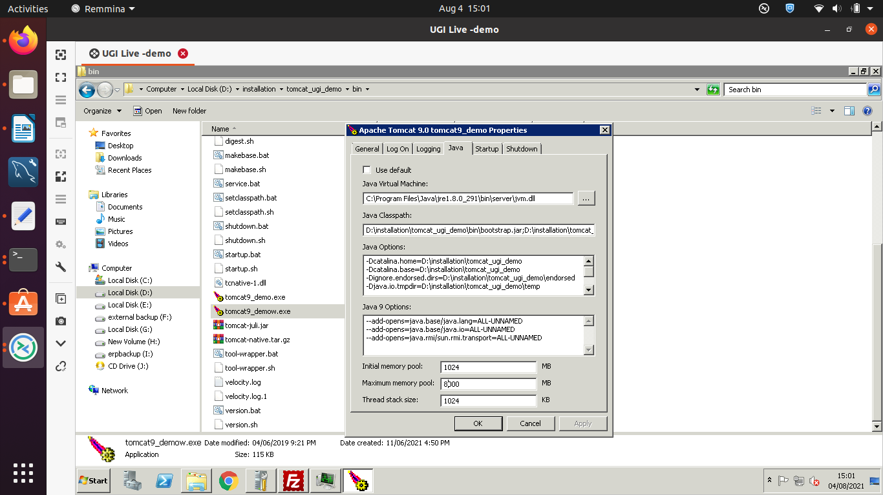***

***==== Know URL =====***

***#cd /etc/apache2/sites-available***

***#ls***

***==== apache2 error check =====***

***#apachectl configtest***

***apache2 – setting – request – set – client***

***vim /etc/apache2/mods-available/mpm\_prefork.conf***

***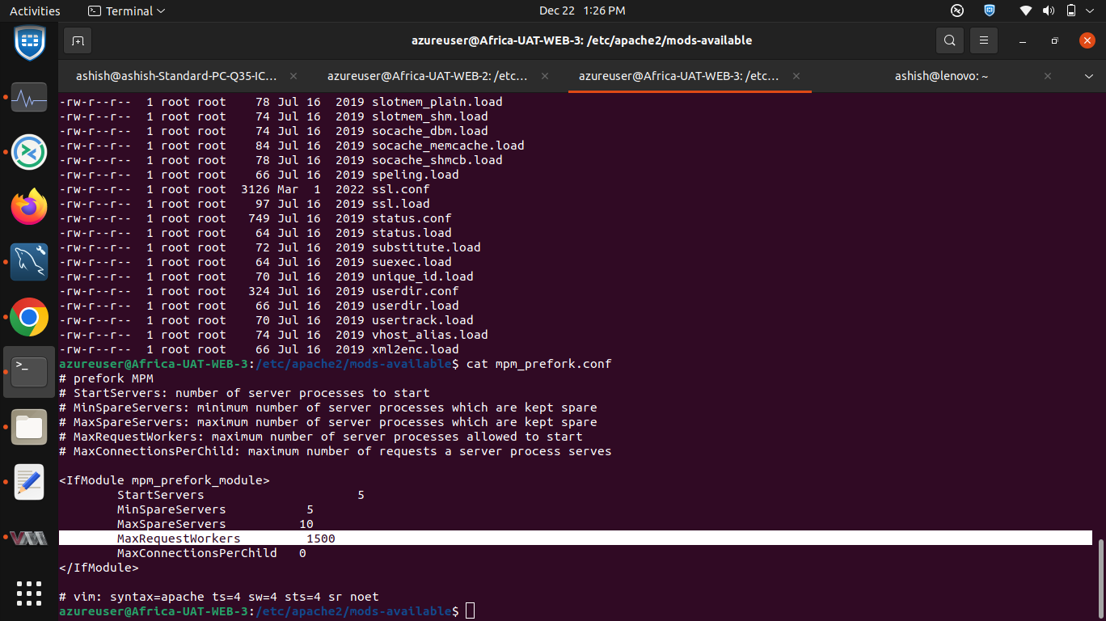***

***==== job sepration =====***

take *a* erp instance service jar to local

cd *opt/serosoft/tomcat\_school\_od/webapps/school\_od/WEB-INF/lib/****serosoft-academia-service-1.0-SNAPSHOT.jar***

and chnge some point

open ***serosoft-academia-service-1.0-SNAPSHOT.jar by zip***

***‘/config/quartz-tomcat.properties***

***1- quartzTomcatUrl=***[***http://localhost:8082/serosoft-academia-web***](http://localhost:8082/serosoft-academia-web)

***4-* isJobtomcat=1**

***change to***

**1- quartzTomcatUrl=**[**http://12.0.3.4:38080/collegetest**](http://12.0.3.4:38080/collegetest)

**and change to also it**

**4- isJobtomcat=0**

**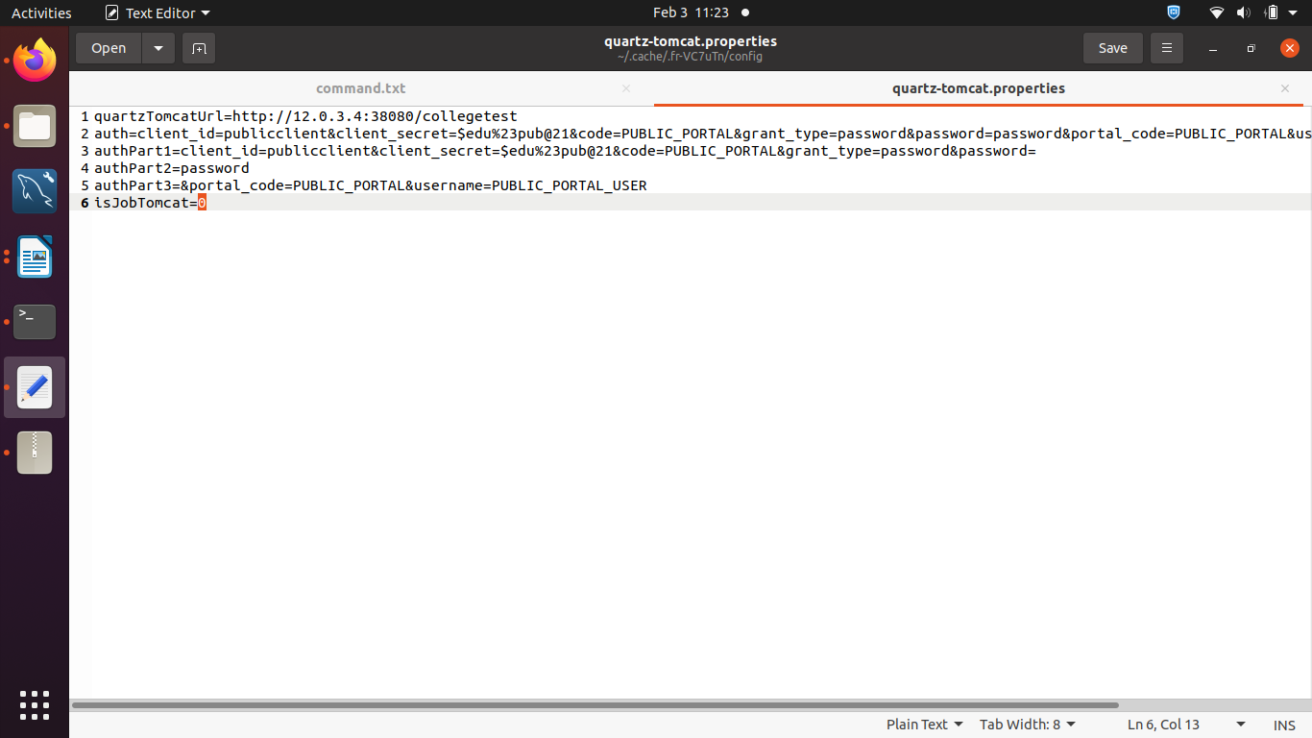**

***check the job-sepration “ ip, port and instance folder name***

***location ( # cd /opt/serosoft/job\_tomcat\_college\_od/conf$ vi server.xml)***

***<Connector port="28080" protocol="HTTP/1.1"***

***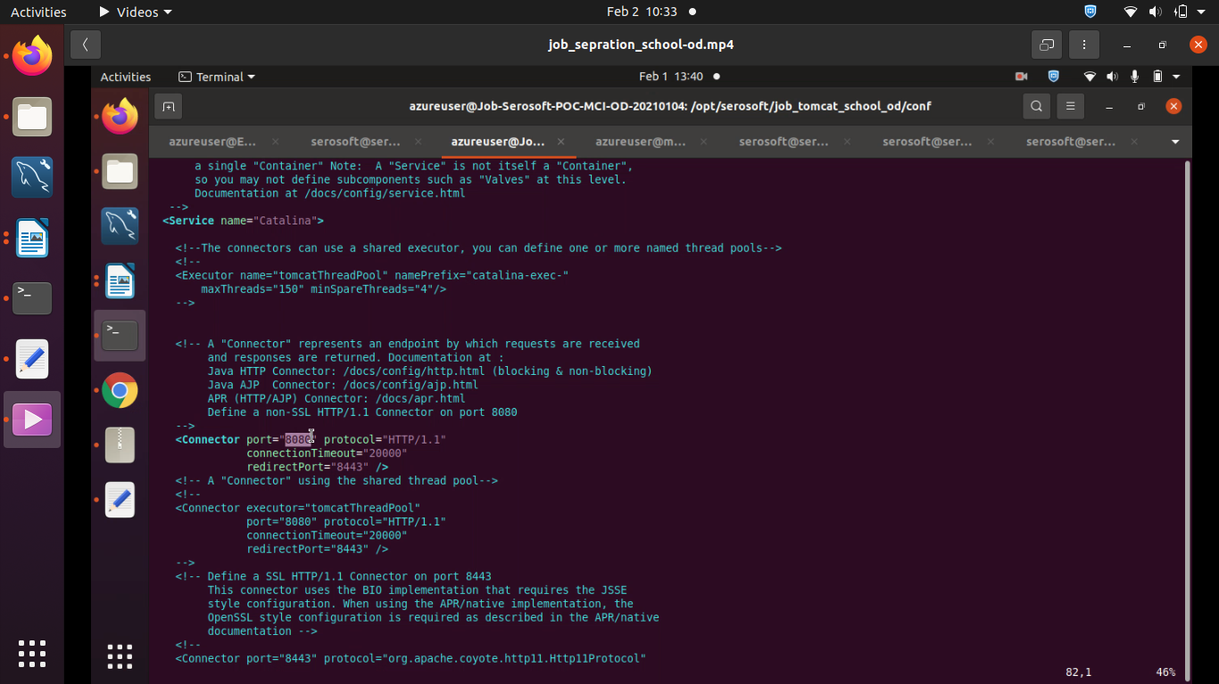***

***also change job-server service jar***

***the ​ Job Tomcat​ it is set to 1.For the ​ Main Tomcat ​ it will be set to 0.***

**after upload jar file**

***#cd /etc/apache2/sites-available***

**==== MS Team =====**

**1- login instance**

**2- copy data to remote server and run below command and password**

**Commands:**

**=====MS Team ========**

**smbclient //10.253.1.151/Schools\_Data\_Sync\_sds$ -U vpn/Schools\_Data\_Sync -W vpn.advtech.co.za -m SMB2 -c 'put "MSTeam-CSV-SDS.zip"'**

**smbclient //10.253.1.151/Schools\_Data\_Sync\_cisk$ -U vpn/Schools\_Data\_Sync -W vpn.advtech.co.za -m SMB2 -c 'put "MSTeam-CSV-CISK.zip"'**

**smbclient //10.253.1.151/Schools\_Data\_Sync\_cisk\_lg$ -U vpn/Schools\_Data\_Sync -W vpn.advtech.co.za -m SMB2 -c 'put "MSTeam-CSV-CISK-LG.zip"'**

**smbclient //10.253.1.151/Schools\_Data\_Sync\_sds\_lg$ -U vpn/Schools\_Data\_Sync -W vpn.advtech.co.za -m SMB2 -c 'put "MSTeam-CSV-SDS-LG.zip"'**

**Password: 3z.oFy=D-&eWw#IYtoW~**

**=====================================================**

***3- review and submit***

***$db\_host = "12.0.3.27"; //hostname***

***$db\_user = "ss\_root"; // username***

***$db\_password = "s3r0s0ft"; // password***

***$db\_name = "vgu\_demo\_applynow"; //database name***

***OS 18.04***

***micro service jar start***

*#cd /opt/serosoft/serosoft-microservice*

*#sudo systemctl daemon-reload  
#sudo systemctl enable serosoft-microservice.service  
#sudo systemctl start serosoft-microservice  
#sudo systemctl status serosoft-microservice*

***OS 14.04***

***micro service jar start***

***#****cd /opt/serosoft/serosoft-microservice*

*#nohup java -Xms128m -Xmx256m -jar in.serosoft.ms-0.0.1-SNAPSHOT.jar & > nohup.out*

*(and change the memory “Xms128m -Xmx256m” )*

*or*

*#nohup java -Xmx3072m -Xss512k -jar serosoft-email-sync-0.0.1-SNAPSHOT.jar &*

*===== OS version check====Monitoring VM*

*#uname -a*

*#cat /proc/cpuinfo*

*#lsb\_release -a*

*cat /etc/os-release*

*==================uptime == last shutdonw*

*#uptime*

*#last -x shutdown | head -1*

*#df -h*

*#free -h*

*#top*

*#ss -tulpn*

*CREATE USER 'akash'@'%' IDENTIFIED BY 'Akash@123';*

*GRANT ALL PRIVILEGES ON \*.\* TO 'akash'@'%' WITH GRANT OPTION;*

*FLUSH PRIVILEGES;*

*Ctrl+A or Home – moves the cursor to the start of a line.*

* Ctrl+E or End – moves the cursor to the end of the line.
* Ctrl+B or Left Arrow – moves the cursor back one character at a time.
* Ctrl+F or Right Arrow – moves the cursor forward one character at a time.
* Ctrl + Left Arrow or Alt+B or Esc and then B – moves the cursor back one word at a time.
* Ctrl + Right Arrow or Alt+C or Esc and then F – moves the cursor forward one word at a time.

*Ctrl+L – clears the screen (same effect as the “clear” command).*

* Ctrl+S – pause all command output to the screen. If you have executed a command that produces verbose, long output, use this to pause the output scrolling down the screen.
* Ctrl+Q – resume output to the screen after pausing it with Ctrl+S.

*-----------*

*https://tecadmin.net/delete-files-older-x-days/*

#find /var/log -name "\*.log" -type f -mtime +30

Above command will delete only files having .log extension and last modification date is older than 30 days

***====================nfs-server==port - 2049===================  
  
sudo apt-get install nfs-kernel-server  
sudo vim /etc/exports  
  
/var/www/html/sis \*(rw,sync,no\_root\_squash,subtree\_check)  
  
sudo service nfs-kernel-server restart  
sudo exportfs  
  
===============================================================  
nfs-client  
  
sudo apt-get install nfs-common  
      
sudo vim /etc/fstab  
  
10.0.2.5:/var/www/html/aei /var/www/html/aei nfs defaults 0 0  
  
sudo mount -avvv  
df -Th***

***====================end====nfs=====================***

***Buzz UAT API integration is currently down after instance update.***

[https://buzzintegration.](https://buzzintegration.academiaerp.com/resources/index.html#_blank)

***Buzz UAT API integration is currently down after instance update.***

[https://buzzintegration.](https://buzzintegration.academiaerp.com/resources/index.html#_blank)

***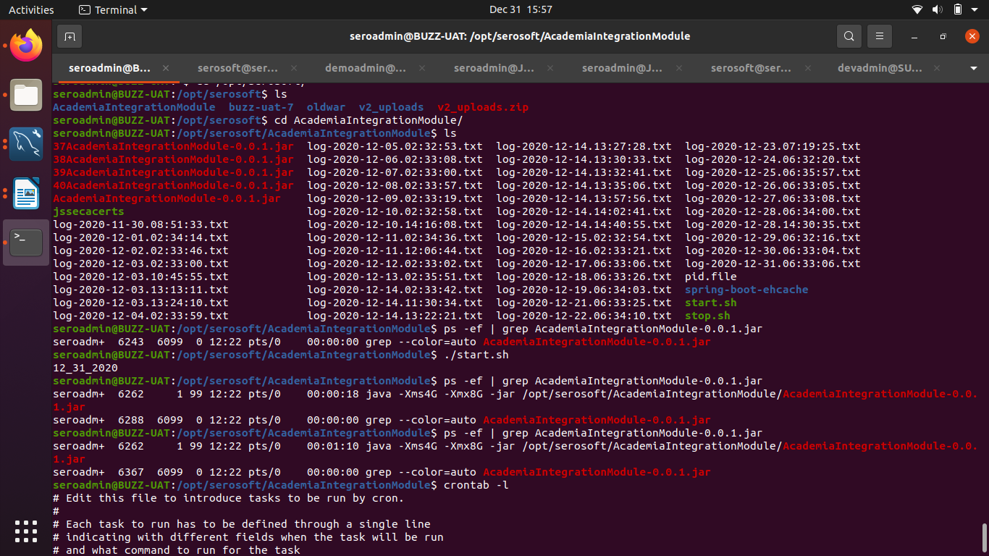***

# *#sudo wget https://stasy-uat1b.academiaerp.com/resources/images/newUI/bg\_image.png*

***#sudo wget --no-check-certificate https://stasy-uat1b.academiaerp.com/resources/images/newUI/bg\_image.png***

***#ls -ltr***

***#sudo mv bg\_image.png.1 bg\_image.png***

***=============================***

***remove “applicat” or***

***go to home***

***Change From <li> to <li style="display:none;">***

***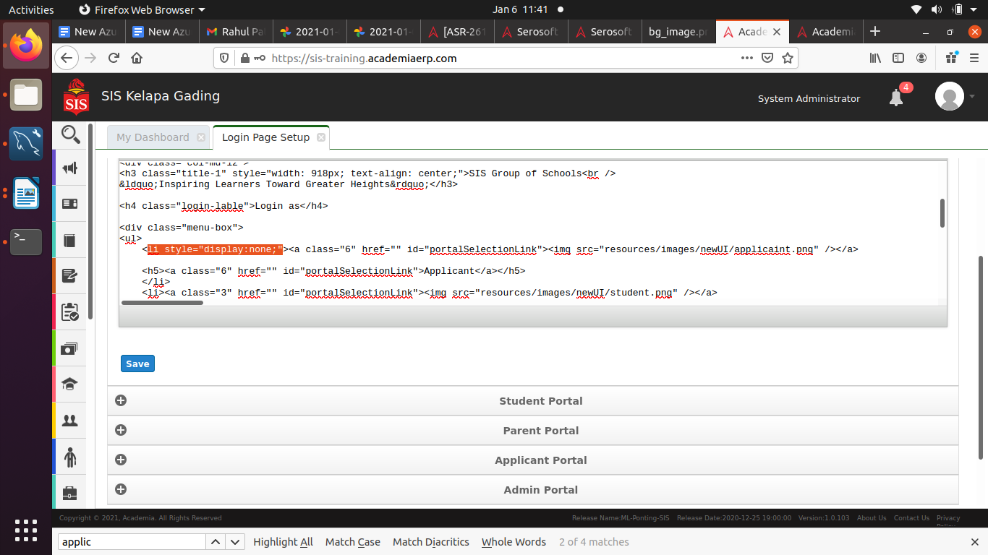***

# *============================*

# *run job seed value for the https://handson.academiaerp.com/ instance.*

***Login database after***

***mysql > use handson;***

***after run scrit***

***-- Insert statements to enable quartz job in the application. Contact Deepak for any question***

***===start ====***

SET FOREIGN\_KEY\_CHECKS=0;

DROP TABLE IF EXISTS `QRTZ\_BLOB\_TRIGGERS`;

DROP TABLE IF EXISTS `qrtz\_blob\_triggers`;

DROP TABLE IF EXISTS `QRTZ\_CALENDARS`;

DROP TABLE IF EXISTS `qrtz\_calendars`;

DROP TABLE IF EXISTS `QRTZ\_CRON\_TRIGGERS`;

DROP TABLE IF EXISTS `qrtz\_cron\_triggers`;

DROP TABLE IF EXISTS `QRTZ\_FIRED\_TRIGGERS`;

DROP TABLE IF EXISTS `qrtz\_fired\_triggers`;

DROP TABLE IF EXISTS `QRTZ\_JOB\_DETAILS`;

DROP TABLE IF EXISTS `qrtz\_job\_details`;

DROP TABLE IF EXISTS `QRTZ\_JOB\_LISTENERS`;

DROP TABLE IF EXISTS `qrtz\_job\_listeners`;

DROP TABLE IF EXISTS `QRTZ\_LOCKS`;

DROP TABLE IF EXISTS `qrtz\_locks`;

DROP TABLE IF EXISTS `QRTZ\_PAUSED\_TRIGGER\_GRPS`;

DROP TABLE IF EXISTS `qrtz\_paused\_trigger\_grps`;

DROP TABLE IF EXISTS `QRTZ\_SCHEDULER\_STATE`;

DROP TABLE IF EXISTS `qrtz\_scheduler\_state`;

DROP TABLE IF EXISTS `QRTZ\_SIMPLE\_TRIGGERS`;

DROP TABLE IF EXISTS `qrtz\_simple\_triggers`;

DROP TABLE IF EXISTS `QRTZ\_TRIGGER\_LISTENERS`;

DROP TABLE IF EXISTS `qrtz\_trigger\_listeners`;

DROP TABLE IF EXISTS `QRTZ\_TRIGGERS`;

DROP TABLE IF EXISTS `qrtz\_triggers`;

DROP TABLE IF EXISTS `QRTZ\_SIMPROP\_TRIGGERS`;

DROP TABLE IF EXISTS `qrtz\_simprop\_triggers`;

/\* From 2.2.1 \*/

DROP TABLE IF EXISTS QRTZ\_FIRED\_TRIGGERS;

DROP TABLE IF EXISTS qrtz\_fired\_triggers;

DROP TABLE IF EXISTS QRTZ\_PAUSED\_TRIGGER\_GRPS;

DROP TABLE IF EXISTS qrtz\_paused\_trigger\_grps;

DROP TABLE IF EXISTS QRTZ\_SCHEDULER\_STATE;

DROP TABLE IF EXISTS qrtz\_scheduler\_state;

DROP TABLE IF EXISTS QRTZ\_LOCKS;

DROP TABLE IF EXISTS qrtz\_locks;

DROP TABLE IF EXISTS QRTZ\_SIMPLE\_TRIGGERS;

DROP TABLE IF EXISTS qrtz\_simple\_triggers;

DROP TABLE IF EXISTS QRTZ\_SIMPROP\_TRIGGERS;

DROP TABLE IF EXISTS qrtz\_simprop\_triggers;

DROP TABLE IF EXISTS QRTZ\_CRON\_TRIGGERS;

DROP TABLE IF EXISTS qrtz\_cron\_triggers;

DROP TABLE IF EXISTS QRTZ\_BLOB\_TRIGGERS;

DROP TABLE IF EXISTS qrtz\_blob\_triggers;

DROP TABLE IF EXISTS QRTZ\_TRIGGERS;

DROP TABLE IF EXISTS qrtz\_triggers;

DROP TABLE IF EXISTS QRTZ\_JOB\_DETAILS;

DROP TABLE IF EXISTS qrtz\_job\_details;

DROP TABLE IF EXISTS QRTZ\_CALENDARS;

DROP TABLE IF EXISTS qrtz\_calendars;

CREATE TABLE QRTZ\_JOB\_DETAILS(

SCHED\_NAME VARCHAR(120) NOT NULL,

JOB\_NAME VARCHAR(200) NOT NULL,

JOB\_GROUP VARCHAR(200) NOT NULL,

DESCRIPTION VARCHAR(250) NULL,

JOB\_CLASS\_NAME VARCHAR(250) NOT NULL,

IS\_DURABLE VARCHAR(1) NOT NULL,

IS\_NONCONCURRENT VARCHAR(1) NOT NULL,

IS\_UPDATE\_DATA VARCHAR(1) NOT NULL,

REQUESTS\_RECOVERY VARCHAR(1) NOT NULL,

JOB\_DATA BLOB NULL,

PRIMARY KEY (SCHED\_NAME,JOB\_NAME,JOB\_GROUP))

ENGINE=InnoDB;

CREATE TABLE QRTZ\_TRIGGERS (

SCHED\_NAME VARCHAR(120) NOT NULL,

TRIGGER\_NAME VARCHAR(200) NOT NULL,

TRIGGER\_GROUP VARCHAR(200) NOT NULL,

JOB\_NAME VARCHAR(200) NOT NULL,

JOB\_GROUP VARCHAR(200) NOT NULL,

DESCRIPTION VARCHAR(250) NULL,

NEXT\_FIRE\_TIME BIGINT(13) NULL,

PREV\_FIRE\_TIME BIGINT(13) NULL,

PRIORITY INTEGER NULL,

TRIGGER\_STATE VARCHAR(16) NOT NULL,

TRIGGER\_TYPE VARCHAR(8) NOT NULL,

START\_TIME BIGINT(13) NOT NULL,

END\_TIME BIGINT(13) NULL,

CALENDAR\_NAME VARCHAR(200) NULL,

MISFIRE\_INSTR SMALLINT(2) NULL,

JOB\_DATA BLOB NULL,

PRIMARY KEY (SCHED\_NAME,TRIGGER\_NAME,TRIGGER\_GROUP),

FOREIGN KEY (SCHED\_NAME,JOB\_NAME,JOB\_GROUP)

REFERENCES QRTZ\_JOB\_DETAILS(SCHED\_NAME,JOB\_NAME,JOB\_GROUP))

ENGINE=InnoDB;

CREATE TABLE QRTZ\_SIMPLE\_TRIGGERS (

SCHED\_NAME VARCHAR(120) NOT NULL,

TRIGGER\_NAME VARCHAR(200) NOT NULL,

TRIGGER\_GROUP VARCHAR(200) NOT NULL,

REPEAT\_COUNT BIGINT(7) NOT NULL,

REPEAT\_INTERVAL BIGINT(12) NOT NULL,

TIMES\_TRIGGERED BIGINT(10) NOT NULL,

PRIMARY KEY (SCHED\_NAME,TRIGGER\_NAME,TRIGGER\_GROUP),

FOREIGN KEY (SCHED\_NAME,TRIGGER\_NAME,TRIGGER\_GROUP)

REFERENCES QRTZ\_TRIGGERS(SCHED\_NAME,TRIGGER\_NAME,TRIGGER\_GROUP))

ENGINE=InnoDB;

CREATE TABLE QRTZ\_CRON\_TRIGGERS (

SCHED\_NAME VARCHAR(120) NOT NULL,

TRIGGER\_NAME VARCHAR(200) NOT NULL,

TRIGGER\_GROUP VARCHAR(200) NOT NULL,

CRON\_EXPRESSION VARCHAR(120) NOT NULL,

TIME\_ZONE\_ID VARCHAR(80),

PRIMARY KEY (SCHED\_NAME,TRIGGER\_NAME,TRIGGER\_GROUP),

FOREIGN KEY (SCHED\_NAME,TRIGGER\_NAME,TRIGGER\_GROUP)

REFERENCES QRTZ\_TRIGGERS(SCHED\_NAME,TRIGGER\_NAME,TRIGGER\_GROUP))

ENGINE=InnoDB;

CREATE TABLE QRTZ\_SIMPROP\_TRIGGERS

(

SCHED\_NAME VARCHAR(120) NOT NULL,

TRIGGER\_NAME VARCHAR(200) NOT NULL,

TRIGGER\_GROUP VARCHAR(200) NOT NULL,

STR\_PROP\_1 VARCHAR(512) NULL,

STR\_PROP\_2 VARCHAR(512) NULL,

STR\_PROP\_3 VARCHAR(512) NULL,

INT\_PROP\_1 INT NULL,

INT\_PROP\_2 INT NULL,

LONG\_PROP\_1 BIGINT NULL,

LONG\_PROP\_2 BIGINT NULL,

DEC\_PROP\_1 NUMERIC(13,4) NULL,

DEC\_PROP\_2 NUMERIC(13,4) NULL,

BOOL\_PROP\_1 VARCHAR(1) NULL,

BOOL\_PROP\_2 VARCHAR(1) NULL,

PRIMARY KEY (SCHED\_NAME,TRIGGER\_NAME,TRIGGER\_GROUP),

FOREIGN KEY (SCHED\_NAME,TRIGGER\_NAME,TRIGGER\_GROUP)

REFERENCES QRTZ\_TRIGGERS(SCHED\_NAME,TRIGGER\_NAME,TRIGGER\_GROUP))

ENGINE=InnoDB;

CREATE TABLE QRTZ\_BLOB\_TRIGGERS (

SCHED\_NAME VARCHAR(120) NOT NULL,

TRIGGER\_NAME VARCHAR(200) NOT NULL,

TRIGGER\_GROUP VARCHAR(200) NOT NULL,

BLOB\_DATA BLOB NULL,

PRIMARY KEY (SCHED\_NAME,TRIGGER\_NAME,TRIGGER\_GROUP),

INDEX (SCHED\_NAME,TRIGGER\_NAME, TRIGGER\_GROUP),

FOREIGN KEY (SCHED\_NAME,TRIGGER\_NAME,TRIGGER\_GROUP)

REFERENCES QRTZ\_TRIGGERS(SCHED\_NAME,TRIGGER\_NAME,TRIGGER\_GROUP))

ENGINE=InnoDB;

CREATE TABLE QRTZ\_CALENDARS (

SCHED\_NAME VARCHAR(120) NOT NULL,

CALENDAR\_NAME VARCHAR(200) NOT NULL,

CALENDAR BLOB NOT NULL,

PRIMARY KEY (SCHED\_NAME,CALENDAR\_NAME))

ENGINE=InnoDB;

CREATE TABLE QRTZ\_PAUSED\_TRIGGER\_GRPS (

SCHED\_NAME VARCHAR(120) NOT NULL,

TRIGGER\_GROUP VARCHAR(200) NOT NULL,

PRIMARY KEY (SCHED\_NAME,TRIGGER\_GROUP))

ENGINE=InnoDB;

CREATE TABLE QRTZ\_FIRED\_TRIGGERS (

SCHED\_NAME VARCHAR(120) NOT NULL,

ENTRY\_ID VARCHAR(95) NOT NULL,

TRIGGER\_NAME VARCHAR(200) NOT NULL,

TRIGGER\_GROUP VARCHAR(200) NOT NULL,

INSTANCE\_NAME VARCHAR(200) NOT NULL,

FIRED\_TIME BIGINT(13) NOT NULL,

SCHED\_TIME BIGINT(13) NOT NULL,

PRIORITY INTEGER NOT NULL,

STATE VARCHAR(16) NOT NULL,

JOB\_NAME VARCHAR(200) NULL,

JOB\_GROUP VARCHAR(200) NULL,

IS\_NONCONCURRENT VARCHAR(1) NULL,

REQUESTS\_RECOVERY VARCHAR(1) NULL,

PRIMARY KEY (SCHED\_NAME,ENTRY\_ID))

ENGINE=InnoDB;

CREATE TABLE QRTZ\_SCHEDULER\_STATE (

SCHED\_NAME VARCHAR(120) NOT NULL,

INSTANCE\_NAME VARCHAR(200) NOT NULL,

LAST\_CHECKIN\_TIME BIGINT(13) NOT NULL,

CHECKIN\_INTERVAL BIGINT(13) NOT NULL,

PRIMARY KEY (SCHED\_NAME,INSTANCE\_NAME))

ENGINE=InnoDB;

CREATE TABLE QRTZ\_LOCKS (

SCHED\_NAME VARCHAR(120) NOT NULL,

LOCK\_NAME VARCHAR(40) NOT NULL,

PRIMARY KEY (SCHED\_NAME,LOCK\_NAME))

ENGINE=InnoDB;

CREATE INDEX IDX\_QRTZ\_J\_REQ\_RECOVERY ON QRTZ\_JOB\_DETAILS(SCHED\_NAME,REQUESTS\_RECOVERY);

CREATE INDEX IDX\_QRTZ\_J\_GRP ON QRTZ\_JOB\_DETAILS(SCHED\_NAME,JOB\_GROUP);

CREATE INDEX IDX\_QRTZ\_T\_J ON QRTZ\_TRIGGERS(SCHED\_NAME,JOB\_NAME,JOB\_GROUP);

CREATE INDEX IDX\_QRTZ\_T\_JG ON QRTZ\_TRIGGERS(SCHED\_NAME,JOB\_GROUP);

CREATE INDEX IDX\_QRTZ\_T\_C ON QRTZ\_TRIGGERS(SCHED\_NAME,CALENDAR\_NAME);

CREATE INDEX IDX\_QRTZ\_T\_G ON QRTZ\_TRIGGERS(SCHED\_NAME,TRIGGER\_GROUP);

CREATE INDEX IDX\_QRTZ\_T\_STATE ON QRTZ\_TRIGGERS(SCHED\_NAME,TRIGGER\_STATE);

CREATE INDEX IDX\_QRTZ\_T\_N\_STATE ON QRTZ\_TRIGGERS(SCHED\_NAME,TRIGGER\_NAME,TRIGGER\_GROUP,TRIGGER\_STATE);

CREATE INDEX IDX\_QRTZ\_T\_N\_G\_STATE ON QRTZ\_TRIGGERS(SCHED\_NAME,TRIGGER\_GROUP,TRIGGER\_STATE);

CREATE INDEX IDX\_QRTZ\_T\_NEXT\_FIRE\_TIME ON QRTZ\_TRIGGERS(SCHED\_NAME,NEXT\_FIRE\_TIME);

CREATE INDEX IDX\_QRTZ\_T\_NFT\_ST ON QRTZ\_TRIGGERS(SCHED\_NAME,TRIGGER\_STATE,NEXT\_FIRE\_TIME);

CREATE INDEX IDX\_QRTZ\_T\_NFT\_MISFIRE ON QRTZ\_TRIGGERS(SCHED\_NAME,MISFIRE\_INSTR,NEXT\_FIRE\_TIME);

CREATE INDEX IDX\_QRTZ\_T\_NFT\_ST\_MISFIRE ON QRTZ\_TRIGGERS(SCHED\_NAME,MISFIRE\_INSTR,NEXT\_FIRE\_TIME,TRIGGER\_STATE);

CREATE INDEX IDX\_QRTZ\_T\_NFT\_ST\_MISFIRE\_GRP ON QRTZ\_TRIGGERS(SCHED\_NAME,MISFIRE\_INSTR,NEXT\_FIRE\_TIME,TRIGGER\_GROUP,TRIGGER\_STATE);

CREATE INDEX IDX\_QRTZ\_FT\_TRIG\_INST\_NAME ON QRTZ\_FIRED\_TRIGGERS(SCHED\_NAME,INSTANCE\_NAME);

CREATE INDEX IDX\_QRTZ\_FT\_INST\_JOB\_REQ\_RCVRY ON QRTZ\_FIRED\_TRIGGERS(SCHED\_NAME,INSTANCE\_NAME,REQUESTS\_RECOVERY);

CREATE INDEX IDX\_QRTZ\_FT\_J\_G ON QRTZ\_FIRED\_TRIGGERS(SCHED\_NAME,JOB\_NAME,JOB\_GROUP);

CREATE INDEX IDX\_QRTZ\_FT\_JG ON QRTZ\_FIRED\_TRIGGERS(SCHED\_NAME,JOB\_GROUP);

CREATE INDEX IDX\_QRTZ\_FT\_T\_G ON QRTZ\_FIRED\_TRIGGERS(SCHED\_NAME,TRIGGER\_NAME,TRIGGER\_GROUP);

CREATE INDEX IDX\_QRTZ\_FT\_TG ON QRTZ\_FIRED\_TRIGGERS(SCHED\_NAME,TRIGGER\_GROUP);

commit;

SET FOREIGN\_KEY\_CHECKS=1;

***=====end===***

***==== NFS server configuration process ====***

***server side***

#### *Step 1: Install NFS Kernel Server in Ubuntu 18.04*

*$ sudo apt update*

*$ sudo apt install nfs-kernel-server*

*$ sudo apt install nfs-kernel-server*

*$ sudo mkdir -p /mnt/nfs\_share (create nfs folder)*

*$sudo chown -R nobody:nogroup /mnt/nfs\_share/*

*$sudo chmod 777 /mnt/nfs\_share/*

*$ sudo vim /etc/exports*

*/mnt/nfs\_share 192.168.43.0/24(rw,sync,no\_subtree\_check)*

*or*

*/mnt/nfs\_share client\_IP\_1 (re,sync,no\_subtree\_check)*

* *rw: Stands for Read/Write.*
* sync: Requires changes to be written to the disk before they are applied.
* No\_subtree\_check: Eliminates subtree checking.

*$ sudo exportfs -a*

*$sudo exportfs -v (for checking)*

$ sudo systemctl restart nfs-kernel-server

*$ sudo ufw allow from 192.168.43.0/24 to any port nfs*

*$ sudo ufw enable*

$ sudo ufw status

***client side***

*$sudo apt update*

*$ sudo apt install nfs-common*

*$ sudo mkdir -p /mnt/nfs\_clientshare*

*$ ifconfig*

*$ sudo mount 192.168.43.234:/mnt/nfs\_share /mnt/nfs\_clientshare*

*check*

*$ cd /mnt/nfs\_share/*

$ touch file1.txt file2.txt file3.txt

***==== End NFS server configuration End ====***

***==== rabitmq service =====***

*#systemctl status rabbitmq-server.service*

***=D:#2\_uploadssangam\_demo/***

***<li><a class="7" href="" id="portalSelectionLink"><img src="resources/images/newUI/parent.png" /></a>***

***<h5><a class="7" href="" id="portalSelectionLink">Parent/Guardian</a></h5>***

***</li>***

***user seroadmin  
password  Sun@shine#321  
for ERP***

***ssh*** [***seroadmin@sunshine-erp.southafricanorth.cloudapp.azure.com***](mailto:seroadmin@sunshine-erp.southafricanorth.cloudapp.azure.com)

***1 apt-get install apache2***

***2 apt-get install libapache2-mod-security2***

***3 apt-get install libapache2-mod-jk***

***4 apt-get update***

***5 apt-get install libapache2-mod-security2***

***6 apt-get install libapache2-mod-jk***

***7 apt-get install php libapache2-mod-php***

***8 add-apt-repository ppa:ondrej/php***

***9 apt-get update***

***10 apt-get install php7-gd***

***11 apt-get install php7-gd php7-intl***

***12 apt-get upgrade***

***13 apt-get install php libapache2-mod-php***

***14 php -v***

***15 systemctl status php***

***16 systemctl status php.service***

***17 systemctl status apache2.service***

***18 apache2 -v***

***19 systemctl status php7.2-fpm***

***20 systemctl status php8.0-fpm***

***21 systemctl status php8.0***

***22 systemctl status phpsessionclean.***

***23 apt-get purge 'php\****

***24 apt-get purge php\****

***25 php -v***

***26 history***

***dpkg –list (list of pakages )***

***sudo apt-get --purge remove apache2***

sudo apt-get remove apache2-common

[***https://www.sumitbera.com/completely-uninstall-php-and-mysql-at-ubuntu/***](https://www.sumitbera.com/completely-uninstall-php-and-mysql-at-ubuntu/)

***------------- php mode check ----***

apt list --installed | grep php